Normal Year Water Supply Characterization
In this chapter we quantify and describe the water sources available to CVWD, which include the District’s wells and purchased imported water supplies from CLAWA, the local wholesaler. Surface water, recycled water, desalinated water, water transfers and water exchanges, and conjunctive use are not included in the District’s supply portfolio. Each water source is described below including future actions or projects anticipated to meet future water demands. This chapter examines water volumes reflecting expectations for “average year” conditions. Single-dry and multiple-dry year conditions and catastrophic interruptions are considered in the supply reliability examination in Chapter 7 and in the Water Shortage Contingency Plan (Chapter 8).

Purchased or Imported Water
In periods when production from CVWD wells is insufficient to meet current water demands, the District purchases supplemental water supplies from CLAWA—a State Water Project (SWP) contractor and the local wholesale supplier of imported water to the western San Bernardino Mountains. CLAWA has been delivering imported water to CVWD since 1972. Chart 6-1 illustrates the relationships between well production, purchased water, and annual rainfall from 1980 to 2025.
Chart 6-1 - CVWD Water Supply and Rainfall (1980-2025)
(Source: CVWD Records)
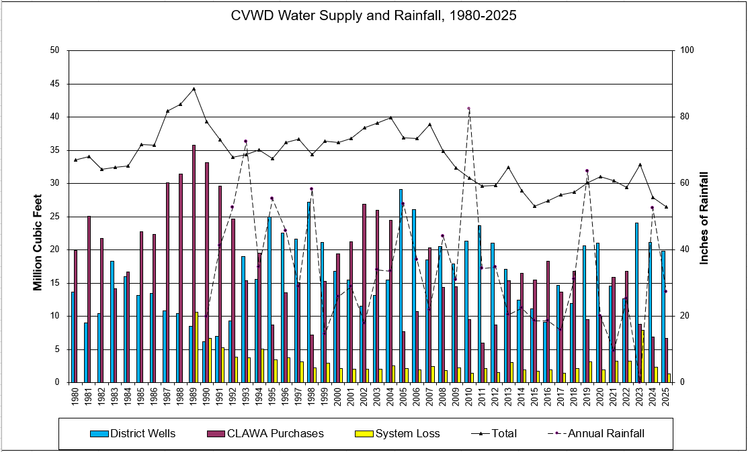
Surface water from Silverwood Lake, which is part of the East Branch of the SWP, comprises CLAWA’s primary source of supply. Pursuant to a contract with DWR, CLAWA is among 29 agencies authorized to receive direct water deliveries from the SWP. Under that contract, CLAWA’s current SWP “Table A” allocation is 5,800 acre-feet (AF) per year, which is just 0.1 percent of the current total maximum Table A (4,172,786 AF). According to the DWR: “The maximum Table A amount is the basis for apportioning water supply and costs to the SWP contractors. Once the total amount of water to be delivered is determined for the year, all available water is allocated in proportion to each contractor’s annual maximum SWP.” (DWR, 2024). It is the maximum amount of water that each contractor is entitled to receive on an annual basis from the SWP and that amount is set forth in “Table A” of each contract with DWR. It is rare that DWR will raise SWP Table A allocations to 100 percent of deliveries, but it did so recently in 2023 due to exceptionally high precipitation, allocating the full amount of 4,172,786 acre feet. (Before 2023, 2006 was the most recent 100-percent allocation year (Osorio, 2020).) Although 2006 was also a 100-percent allocation year, CLAWA’s deliveries were just 11.1 percent of its Table A allocation (Osorio, 2020). Furthermore, while Table A identifies the maximum amount of SWP supplies that the contractors may receive in a year, the actual amount available depends on a variety of hydrologic, operational, environmental, regulatory, legal, and other factors. Chart 6-2 illustrates how different the initial statewide allocation to all SWP Contractors can be from the final SWP allocation, from 1996 to 2020 (Osorio, 2020).
Chart 6-2 - Recorded SWP Allocations for all Contractors (1996-2019) – Initial vs. Final
(Source: Osorio, 2020)
DWR prepares a biennial SWP Delivery Capability Report, which accounts for the many factors affecting the SWP. The report forecasts the long-term annual availability of SWP supplies during normal/wet, single-dry, and multiple-dry year (6-year) periods over the next 20-year forecast. The latest SWP report was considered in this chapter, in the supply reliability presentation in Chapter 7, and in the Water Shortage Contingency Plan in Chapter 8 (SWP DCR 2023, July 2024).
CLAWA also indirectly obtains some of its supply from Huston Creek, which flows into Silverwood Lake when seasonal weather permits. Diversions from this source vary depending on annual precipitation and are limited to the amount of return flow to the Mojave watershed each year. Diversion of water from Huston Creek is subject to two diversion permits, which combined authorize the appropriation of up to 566,280 CCF (1,300 AF) per year to CLAWA. CLAWA's permits for appropriative rights to Huston Creek together with SWP deliveries creates a more reliable water supply in that Huston Creek is able to supplement CLAWA's total water supply. As an example, in 1992-93 an extended drought in Northern California forced the DWR to reduce its SWP deliveries to CLAWA, who in turn was able to use water from Huston Creek to supplement its supply. However, due to the unpredictable nature of local hydrology, CLAWA’s appropriated water from Huston Creek is not as reliable as SWP deliveries (CLAWA 2010 UWMP, August 2011).
CLAWA’s supply portfolio includes a 2005 agreement with Lake Arrowhead Community Services District (LACSD) and San Bernardino Valley Municipal Water District (SBVMWD). During normal years, this arrangement mainly affects LACSD however, during years of low SWP allocation (i.e., drought years) CLAWA has the right to utilize a portion of the water purchased from SBVMWD to satisfy any demands anywhere in CLAWA’s service area. The amount purchased from SBVMWD in any year is limited to 15 percent of SBVMWD’s SWP allocation (CLAWA 2010 UWMP, August 2011).
Similarly in 2010, CLAWA entered into a water exchange agreement with San Gorgonio Pass Water Agency (SGPWA), which stipulated that SGPWA shall deliver to CLAWA up to a total of 1,300 AF of water when requested by CLAWA, between the years 2012 and 2020, subject to the conditions of their 2010 agreement. In 2017 a new exchange agreement was implemented that increased the amount owed to CLAWA from SGPWA to 566,279 CCF (1300 AF). In 2023 Amendment 1 extended the agreement to the end of 2026 for return of the outstanding water.
CLAWA intends to continue to negotiate further exchange agreements with other Contractors as opportunities arise and also continue to “carry over” water in the SWP that was allocated in a given year to CLAWA but not used. (CLAWA UWMP Response Letter, May 6, 2026, Appendix C). Carryover water is a portion of Table A water that contractors may save for next year’s delivery. When carryover is requested for next year’s delivery, that water is stored in the SWP’s share of San Luis reservoir in Merced County. However, SWP contractors can lose this stored carryover water when San Luis Reservoir fills. For example, in 2017, a wet year, three contractors including CLAWA needed to transfer their carryover water from San Luis to another non-SWP facility to prevent losing their carryover storage. (Osorio, 2020)
A representation of the District’s recorded fluctuating dependence on imported supplies from CLAWA beginning in 1980 is provided in Chart 6-3. As shown, during years of drought, purchased water from CLAWA makes up a considerable difference between District wells and 100 percent of supply (i.e., the area in white). For example, in 1990 more than 84 percent of CVWD supplies came from imported water purchased from CLAWA. On the other hand, local CVWD wells have been able to meet nearly 80 percent of customer demand several times over the past 25 years. As Chart 6-3 shows, over the three most recent years, CVWD well water has been able to meet more than 70 percent of customer demand.
Chart 6-3 – Recorded CVWD Sources of Supply, 1980-2025
(Source: CVWD Records)
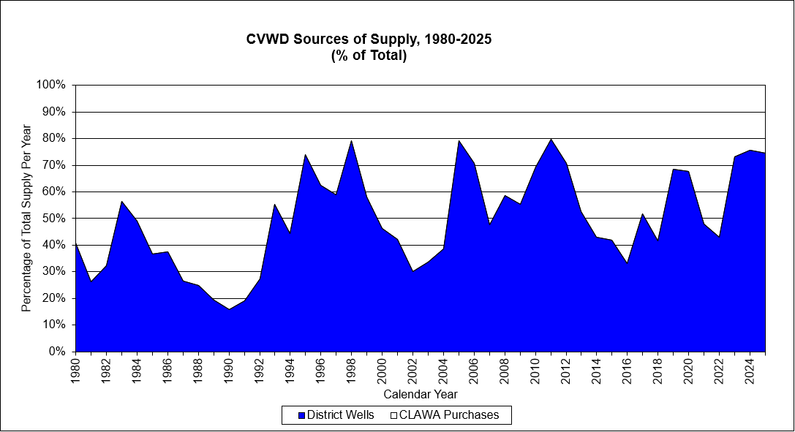

Purchased Water Quality
SWP water is considered high-quality water and is used statewide to serve 25 million residents as a supplemental water source. Chemical, physical, and biological parameters are routinely monitored throughout the SWP from the Feather River drainage in the north to Lake Perris in the south including more than 40 sites and over 200 individual chemicals (MWA, 2016). CLAWA’s water supplies are treated at the Lake Silverwood Water Treatment Plant near the South Shore. After treatment, the water is then pumped uphill to CLAWA’s storage and pipeline distribution system, which extends from Job’s Peak (near Cedarpines Park) eastward to Green Valley Lake. CLAWA maintains consistent compliance with all water quality standards and regulations. The results of each year’s water quality sampling are reported in CLAWA’s annual Consumer Confidence Report, the most recent of which (CY 2025) is provided in Appendix I.

Groundwater
Currently, CVWD produces water locally from 35 groundwater wells in a fractured rock aquifer system (2025 CVWD Annual Report to the SWRCB). The District has had as many as 50 wells in the past. This portion of the San Bernardino Mountains is not included on the California Statewide Groundwater Elevation Monitoring (CASGEM) priority list, or subject to the basin management requirements of the 2014 Sustainable Groundwater Management Act (SGMA) because DWR classifies it as “non-water-bearing.” The area is also not included in DWR’s “Bulletin 118” list of groundwater basin data.
A complex of crystalline granitic rocks that have intruded metaplutonic and metasedimentary rocks make up the San Bernardino Mountains (IGC, 1997). Thus, there are no unconsolidated sediments or traditional groundwater basins in this mountainous area. Instead, groundwater is confined to open fractures in the hard metamorphic and granitic mountain rocks underlying CVWD’s service area. Groundwater is fed by rainfall and snow seeping into fractures along drainage courses, and may discharge down-gradient as a spring, enter the bottom of a drainage feeding a flow, or continue to move down-gradient beneath the surface (USGS, 2002).
The fractured rock aquifers are very different from traditional alluvial groundwater basins in that they yield far smaller volumes, are tightly correlated with precipitation, and there is no “basin” of water to measure in order to calculate metrics such as “safe yield” or “overdraft.” Water is transmitted only through cracks and fractures from the folding and faulting of the rock over time; thus, explaining the difficulty in their ability to collect and store water (Banks & Robins, 2002).
Wells are often placed where groundwater accumulates behind a fault or fracture. Barriers to groundwater flow consist primarily of westerly and northwesterly-trending faults that represent many of the contacts between the different igneous and metamorphic rocks in the San Bernardino Mountains (IGC, 1997). When the flow-path of groundwater is interrupted, for example, due to the presence of a fault, the downslope-moving groundwater accumulates behind the barrier. This causes the water table to rise until it reaches the surface, where it can resume its downslope path as surface water (USGS, 2002). Evidence of groundwater can generally be seen in numerous streams and seeps throughout the area. An recent extraordinary example of this was seen after Crestline received more than 12 feet of snow in 2023 and District personnel witnessed some seeps in the downtown area flowing strongly for more than two years afterward.

Groundwater Quality
The water from CVWD’s wells is of high quality and requires little treatment. CVWD wells are sampled as required by the State Water Board monthly, weekly, and annually. The District maintains consistent compliance with all water quality standards and regulations. The District publishes the results of annual water quality sampling in Annual Consumer Confidence Reports, the most recent of which are located in Appendix J. The District has four chlorination locations for disinfection and five locations where phosphate is injected for corrosive control purposes. One well, Chamois, has higher levels of uranium; however, it is treated by blending with other water sources at the Chamois tank. Water from the recently implemented Electra well shows elevated levels of Gross Alpha radiation, which is a treatable type of energy released when radioactive elements from uranium in the rocks decay or break down. The District added an ion-exchange uranium removal system for this well.

Groundwater Management
Approximately 94 percent of the CVWD service area is within the South Lahontan Hydrologic Region and therefore within the local jurisdiction of the California Regional Water Quality Control Board - Lahontan Region (RWQCB). The remainder of the District is within the South Coast Hydrologic Region under the local jurisdiction of the RWQCB – Santa Ana Region.
CVWD is not located within an adjudicated groundwater basin, nor does CVWD have an adopted groundwater management plan. However, groundwater management actions are ongoing; for example, at the vertical wells the District regularly monitors static water levels and pumping water levels. In CY 2025, levels were reported in the Annual Report as steady over the course of the year with some change according to the season. Horizontal wells are not monitored for static water levels or pumping levels. Well production rates and water quality are also monitored regularly. Likewise, water conservation is encouraged year-round as standard practice.

Overdraft Conditions
Overdraft conditions do not apply in this circumstance because CVWD obtains its local water supply from fractured rock aquifers and not a groundwater basin. However, unlike traditional groundwater basins, fractured bedrock does not typically convey or store large quantities of water. This means that fractured bedrock groundwater supplies are more reliant on local precipitation for recharge. Therefore, CVWD’s local water supply will be diminished in periods when drought conditions persist.

Recorded Groundwater Pumping
The well production from 1980 to 2025 is shown previously in Chart 6-1. The groundwater volumes pumped in the past five years (2021-2025) are shown in Submittal Table 6-1, below.
Submittal Table 6-1: Groundwater Volume Pumped

Surface Water
The District currently does not have direct access to nor plans to use self-supplied surface water as part of its water supply portfolio. Lake Gregory is located within the District and is a predominant feature of the Crestline community. Lake Gregory is a man-made lake and recreation area created with the construction of Lake Gregory dam in 1936. A nearly $25 million seismic retrofit was completed in 2019, adding an average 40 feet of thickness to the earthen dam. CVWD does not have rights to use the lake water, which is fed by Huston Creek and managed by San Bernardino County Special Districts.

Stormwater
Currently, the District does not have plans to use or divert stormwater for beneficial use as part of its water supply portfolio.

Wastewater and Recycled Water
Crestline Sanitation District (CSD) collects, treats, and discharges all wastewater generated within CVWD’s service area. CVWD does not operate any wastewater or recycled water facilities. CSD’s service area covers nearly all of CVWD’s service area, as shown in Figure 6-1 – Crestline Sanitation District. Recycled water is not distributed in the Crestline area.

Wastewater Collection, Treatment, and Disposal
CSD operates three small wastewater treatment plants with a combined capacity of 1.4 million gallons per day (MGD) in the San Bernardino National Forest (see Figure 6-2 – Wastewater Treatment and Discharge). CSD does not contract operation of its plants to a third party. The Huston Creek wastewater treatment plant (WWTP) is located within CVWD’s service area north of Lake Gregory and has a permitted treatment capacity of 0.7 MGD. Most of the wastewater generated within CVWD, except for wastewater from the Valley of Enchantment (VOE) is treated at the Huston Creek WWTP. Wastewater from the VOE is treated by CSD outside of the CVWD service area at CSD’s Seeley Creek WWTP, which has a capacity of 0.5 MGD. The Huston Creek WWTP treats the wastewater from approximately 50 percent of the sewered area, and the Seeley Creek plant serves the other 50 percent.
CSD operates a third facility (Cleghorn WWTP) that is located outside of CVWD’s service area. CSD also disposes of effluent from the Pilot Rock WWTP, also located outside of CVWD’s service area, which is owned by the California Department of Forestry and has a treatment capacity of 0.01 MGD. No wastewater from the CVWD service area is treated at the Cleghorn or Pilot Rock treatment plants and they are not discussed further.
Treated effluent from the CSD treatment plants is conveyed through a single 14-mile outfall pipeline, which flows from the Huston Creek Treatment Plant, down Miller Canyon, to a junction point with the Seeley Creek outfall pipeline. The outfall passes around the south and west boundaries of Silverwood Lake, through Cleghorn Creek, into Summit Valley. The effluent is discharged just below Cedar Springs Dam, near Las Flores Ranch in the high-desert city of Hesperia and is disposed onto the land for irrigation of a nearby pasture area. This effluent land disposal site is located within the Upper Mojave River Valley Basin (Basin No. 6-42).
The Las Flores Ranch has been the effluent disposal site for CSD for over 50 years. CSD currently has no interest in pursuing tertiary treatment or reuse in the mountain area. Wastewater generated in the mountain area can be put to use; however, due to the order issued by the Lahontan RWQCB prohibiting the use of reclaimed water in the Silverwood Lake watershed and above 3,200 feet in the Mojave Hydrologic Unit, wastewater generated in Crestline must be used elsewhere. The wastewater collected by CSD from within CVWD’s service area in CY 2025 is provided in Submittal Table 6-2.
Submittal Table 6-2: Wastewater Collected Within Service Area

The Huston Creek and Seeley Creek WWTPs provide primary treatment, fixed-film (i.e. trickling filter), secondary treatment, and chlorine disinfection. Sludge thickening and dewatering of solids is performed at the Huston Creek WWTP, which also accepts septic tank discharge, treating approximately 160,000 gallons of septage per year. CSD's treated effluent meets the discharge monitoring requirements issued by the Lahontan RWQCB.
The wastewater volume treated within the CVWD service area in 2025 by CSD facilities is provided in Submittal Table 6-3.
Submittal Table 6-3: Wastewater Treatment and Outcomes Within UWMP Service Area

Recycled Water Coordination
The CSD and CVWD service areas are subject to several prohibitions against using recycled water. The Lahontan RWQCB prohibits discharging waste to land or water within the Silverwood Lake watershed (Basin Plan, Ch.4). In addition, discharging waste to land or water is also prohibited above 3,200 feet elevation (approximate elevation of Mojave Forks Dam) in the Deep Creek and Grass Valley Creek watersheds as well as discharging waste to surface water above 3,200 feet in areas tributary to the West Fork Mojave River or Deep Creek. “The discharge of waste from new leaching or percolation systems is also prohibited in the Silverwood Lake watershed, Deep Creek and Grass Valley Creek watersheds above elevation 3,200 feet (for this prohibition, “new” systems are any installed after May 15, 1975)” (Basin Plan, p. 4.1-21). The RWQCB may grant exemptions in situations where discharging waste will not individually or collectively, directly or indirectly, result in exceeding the water quality objectives or unreasonably affecting the water for its beneficial uses.
Further, CSD and CVWD service areas are tributary to Silverwood Lake, which is a source of public drinking water supply. It is not known whether the RWQCB would grant an exemption for discharge of reclaimed wastewater under these circumstances. In the absence of an exemption, no reuse of recycled water is possible at this time.
In the District’s service area, there are no other potential sources of reclaimed water. Although Lake Arrowhead Community Services District (LACSD produces tertiary-treated wastewater effluent, and adjoins CVWD to the east, transporting it from the LACSD treatment facility to CVWD’s service area would require extensive pumping and lengthy pipelines, along with regulatory approvals. Therefore, this plan has been developed under the assumption that no reclaimed water supply will be available for use within CVWD.

Recycled Water System
In addition to the aforementioned regulatory limitations and lack of financial incentive for CSD, there is relatively low potential for recycled water use in the future on the basis of the topography of CVWD’s service area and development patterns. The terrain is steep, winters are severe, and preservation of natural forest conditions is preferred, which means that there are few irrigated areas within the service area. In addition, there are no industrial uses within the service area and commercial uses are fairly small; therefore, the dearth of potential major users of recycled water makes use of recycled water not economically feasible at this time. Because CSD is the only wastewater treatment provider within CVWD’s service area, there will be no current or planned discharge of treated effluent within CVWD’s service area.

Recycled Water Beneficial Uses
Although there are abstractly several beneficial uses of recycled water within the service area, the regulatory and financial constraints create a low potential for actual implementation. As indicated in Submittal Table 6-4, recycled water is not used and is not planned for use in CVWD’s service area.
Submittal Table 6-4: Recycled Water Direct Beneficial Uses Withing Service Area
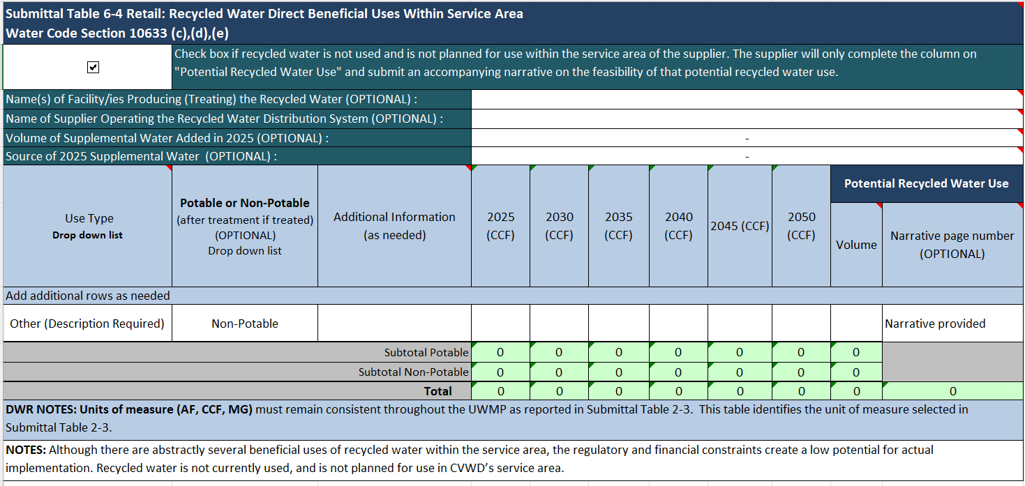
There is also little to no agriculture, irrigation, or industrial uses within CVWD’s service area. Thus, the economic feasibility is low. It could be possible to apply for exceptions to the RWQCB restrictions on recycled water use; however, as there is no market for recycled water within the service area, this option will not be pursued at this time. The 2020 UWMP for CVWD also indicated that recycled water is not expected for use in the future, as shown in Submittal Table 6-5.
Submittal Table 6-5: 2020 UWMP Recycled Water Use Projection Compared to 2025 Actual
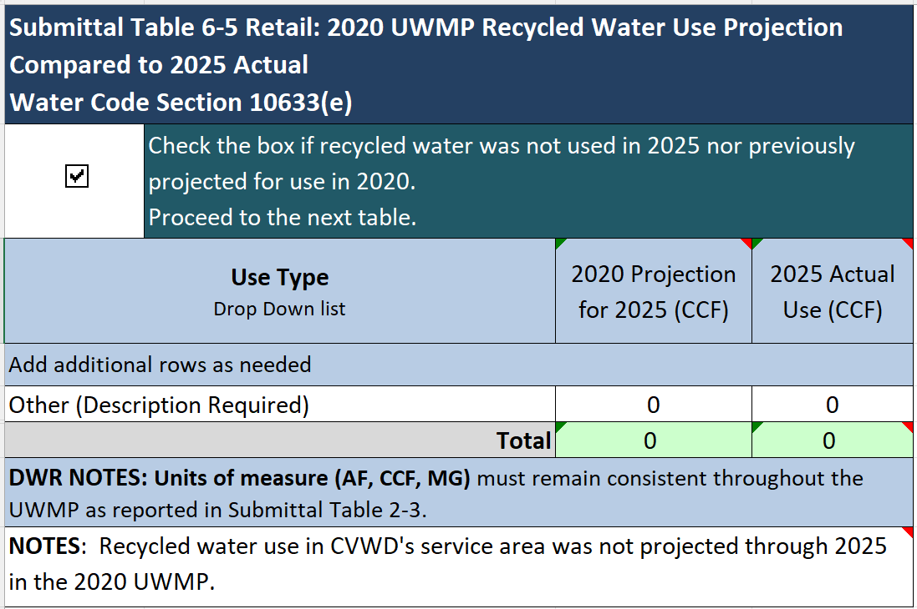

Actions to Encourage and Optimize Future Recycled Water Use
In consultations related to this plan, CSD has indicated that it intends to continue disposing its treated effluent in locations outside of CVWD’s service area. As shown in Submittal Table 6-6, there is no current or planned use of recycled water within CVWD’s service area.
Submittal Table 6-6: Methods to Encourage Future Recycled Water Use
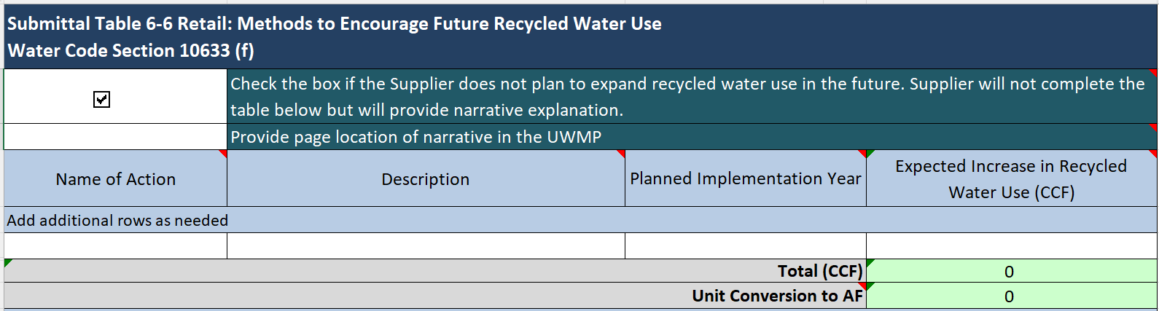

Desalinated Water Opportunities
The District’s service area is remote from any desalinated water supply sources such as the ocean, brackish surface water, and brackish groundwater. As such, there is no need or opportunity to implement desalinization as a water supply source.

Water Exchanges or Transfers
Due to the geographically disseminated locations of local area water purveyors, coupled with the limited availability of local water supply sources, exchanges and/or transfers are not very feasible. Imported water purchased from the local wholesaler, CLAWA, is the most reliable source of supply for many local water purveyors to fill the gap between the difference in local supplies and peak water demands. CLAWA does participate in exchange agreements and water banking and will continue to do so as described earlier in this chapter.

Future Water Supply Projects
The District plans to construct one new water supply well within the next five years (i.e., Pinecrest Vertical Well II), as shown in Submittal Table 6-7. Pinecrest II has a projected yield of approximately 30,000 to 56,000 CCF per year (or 43 gpm to 80 gpm). This well is deemed to be potentially more productive due to a combination of its hydrologic properties. In addition, it will be located at the top of the District, which allows the District to move the water with gravity to nearly all of the other zones, and take advantage of the well’s proximity to the District’s two largest tanks for short-term storage. The pumps CVWD intends to use with this setup will also have the ability to adjust output to accommodate demand.
Should the targeted yields of the proposed Pinecrest II well come to fruition, the increase in water supply would easily outpace the estimated growth in water demands shown on Submittal Table 4-3. However, even with the most hydrogeologic investigative information, the nature of fractured hard rock wells along with their reliance upon annual precipitation makes it very difficult to predict a constant dependable flow 24 hours a day, 365 days per year.
Submittal Table 6-7: Expected Future Water Supply Projects or Programs

Summary of Existing and Planned Sources of Water
A summary of the actual sources and volumes of water produced from CVWD wells and purchases of imported water from CLAWA for CY 2025 is provided in Submittal Table 6-8.
Submittal Table 6-8: Water Supplies—Actual
Future water supplies are projected in Submittal Table 6-9, which take into account future supply projects from Submittal Table 6-7 beginning with actual CY 2025 supplies from Submittal Table 6-8, all of which assumes a normal rainfall year.
Submittal Table 6-9: Water Supplies—Projected
The calculation of District well production supply projections in Submittal Table 6-9 begins with the CY 2025 actual production volume of 197,779 CCF (608 AF) plus the addition of one well by 2028 adding 56,060 CCF (129 AF). Assuming the top range of production, CVWD could produce up to an additional 56,060 CCF by the 2030 projection year and throughout the projection period.
Imported water projections in Table 6-9 are based on DWR’s projected SWP percentage of Table A in a normal year under current conditions (53% of 5,800 AF) but just 30 percent of that is considered reasonably available supply to CVWD. The amount of water shown in Table 6-9 from this source is not an amount the District is committed to using. The future amounts purchased from CLAWA will be only those which are required to meet demand after local wells are fully utilized.
In order to continue meeting customer demand for water, including during shortages, so that the District can ensure at a bare minimum an amount of water to meet the basic health and safety needs of its customers, at least some portion of the District’s future supplies will come from imported water purchased from CLAWA. That amount varies from year to year based on the factors described herein. Over the past 40 years, the balance of supply is on average 50/50. Over the past 26 years (2000-2025), due to the District’s expansion of local groundwater sources, local supplies have averaged approximately 54 percent of total supply. However, the percentage of CVWD supply could reasonably increase to as much as 70 percent depending on climatic conditions. CVWD’s supply projections are predicated on CLAWA’s ability to supply, no matter how the District’s wells are producing. The reliability of both CVWD local supplies and purchased imported water supplies is addressed further in Chapter 7 - Water Service Reliability and Drought Risk Assessment.

Special Conditions

Climate Change Effects
Water Code requires the District to consider the impacts of climate change in its water supply projections, which are shown in Submittal Table 6-9. The District’s considerations for climate change impacts began with using the Climate Change Vulnerability Screening Form for Urban Water Management Planning located in Appendix I to the DWR Guidebook for 2025 UWMPs. A copy of the Screening Form, completed by CVWD staff, is located in Appendix G. Pursuant to Water Code, the District’s planning for climate change impacts is commensurate with the size of the system and its anticipated supply availability under a normal water year, single dry year, and droughts lasting at least five consecutive years, as described below.
As described in Chapters 3 and 4, an analysis of DWR climate data was performed by a large water district located nearby with the ample resources to investigate and analyze climatological models and summarize the potential effects of changes in precipitation and outdoor water use. Western prepared said analysis in a Technical Memorandum dated September 6, 2022, which included the development of water supply change factors (Appendix G).
The water supply factors developed by Western and used herein are provided in Table 6A below. As shown in the factors, the analysis of climate change models found that:
For normal years, precipitation and natural recharge are initially projected to decrease during the first decade before stabilizing during the second decade. The maximum projected range of decrease for normal year values is 1.7 percent. However, the projections show that droughts will initially be less severe from the perspective of local rainfall and recharge for the single dry year with increases of up to 1 percent. Recharge during 5-year droughts is projected to decrease by up to 2.3 percent by 2045. (WMWD(a), p. 11)
Indeed, Western was focusing on its service area in the Inland Empire valley located about 2,000 feet below the elevation of Crestline, therefore, the factors may be conservative in their effect of reducing precipitation given that the mountains receive more rain and far more snow than the valley, are almost always cooler in temperature, and have significantly less outdoor water use.
Table 6A: Water Supply Climate Change Factors for Precipitation and Natural Recharge
Beginning Year | Normal Year | Single-Dry Year | Five-Year Dry Period
2020⁽¹⁾ | 100.0% | 100.0% | 100.0%
2025 | 99.2% | 99.3% | 98.7%
2030 | 98.4% | 98.5% | 97.6%
2035 | 98.0% | 97.7% | 96.8%
2040 | 97.7% | 97.0% | 96.2%
2045 | 97.3% | 96.0% | 95.6%
Source: Western Municipal Water District, Technical Memorandum: Western Drought Contingency Plan – Climate Change Vulnerability Assessment, September 6, 2022 (WMWD).
(1) 2020 is baseline year.

To account for the potential effects of climate change to water supplies, and the uncertainty therein, CVWD has conservatively applied the normal year factors from Western’s analysis in Table 6A to the groundwater supply projections of Submittal Table 6-9 beginning in 2025 through 2040. The results are shown below in Table 6B.
Table 6B: Potential Effect of Climate Change to Normal Year Projected Supplies
 | 2025 | 2030 | 2035 | 2040 | 2045
TOTAL SUPPLY (CCF)⁽¹⁾ | 655,569 | 655,569 | 655,569 | 655,569 | 655,569
Supply from Groundwater (CCF)⁽¹⁾ | 253,859 | 253,859 | 253,859 | 253,859 | 253,859
Water Supply Climate Change Factor (Groundwater) ⁽²⁾ | 99.2% | 98.4% | 98.0% | 97.7% | 97.3%
Groundwater Supply with Climate Change Factor (CCF) | 251,828 | 249,797 | 248,782 | 248,020 | 247,005
Potential Change in Total Supply from Climate Change Effects (CCF) | -2,031 | -4,062 | -5,077 | -5,839 | -6,854
Total Supply with Climate Change Factor (CCF) | 653,538 | 651,507 | 650,492 | 649,730 | 648,715
Notes: Units in hundred cubic feet (CCF).
⁽¹ ⁾ From Submittal Table 6-9.
⁽²⁾ Climate change factors from Table 2A (WMWD).

Regulatory Conditions and Project Development
Constraints to the District’s water supplies are discussed in Chapter 7. In summary, wells in fractured bedrock are constrained by limited production rates compared to wells in alluvial soils, and they are constrained by responsiveness to rainfall. Constraints to imported water supplies include reductions made by DWR in annual allocations as a result of varying hydrological, regulatory, and environmental factors. Further, all supplies are constrained by infrastructure limitations or failures of pipelines or pumps. All supplies can also be constrained due to water quality issues. Regulations for yet-to-be determined emerging contaminants in water may influence existing and future water supplies to some degree. Said effects could include how future well sites are located and what wellhead treatment(s) and/or blending are needed and subsequent costs to do so.

Other Locally Applicable Criteria
Wildfires are always a threat to the mountainous region of Crestline, particularly in times of extended drought exacerbated by climate change. The mountain vegetation may be drier and more vulnerable to become fuel if a spark occurs as temperatures increase. The primary concern from fires on CVWD’s local water supply is disruption of power, thereby requiring the use of standby generators. CVWD maintains a system of water tanks throughout its service area that have storage volumes sized for providing adequate fire flows. To protect this equipment, the District maintains a regular schedule of clearing vegetation around its above-ground structures. CVWD also relies on purchases of imported SWP water from Silverwood Lake. When large areas of the forest surrounding the lake burned in 2003, mulch was laid down to limit erosion (CLAWA 2010 UWMP).
Although the District does not experience an exaggerated risk of flooding resulting from the after-effects of wildfires, some flooding is anticipated in certain canyons during rain events. As growth continues, the District will evaluate each pressure zone and the fire flow requirements to determine if and when additional tanks are necessary and locating them in places where flooding is not anticipated.
There are no other locally applicable criteria that would affect characterization and availability of the District’s existing or future water supply.

Energy Use
Energy is required to operate a water supply system, including the energy needed to pump, treat, store, and deliver water to the end consumer. Water Code Section 10631.2(a) requires that the UWMP report estimates of the energy used for the water distribution system that is within the District’s operational control.
CVWD obtained electricity usage data from its electricity supplier, Southern California Edison for CY 2025 for each electrical meter located at each of the District’s facilities. This includes CVWD water wells, booster stations, tanks, and pressure reducing stations. Total electricity used for the water distribution system in CY 2025 was 455,671 kilowatt hours (kWh), as shown in Table 6-O1B. Energy intensity based on water supplied in CY 2025 was calculated to be 2,300 kWh per CCF supplied. The District does not use solar power or other self-generated renewable energy, nor hydropower.
Submittal Table O-1B: Recommended Energy Reporting – Single Delivery Product – Total Utility Approach

Figure 6-1 – Crestline Sanitation District

Figure 6-2 – Wastewater Treatment and Discharge

Sometimes spelled “Houston.”
Permits issued by SWRCB in 1991. One permit authorizes the diversion of up to 1,000 AF per year, the other up to 300 AF per year. Prior to issuance of these permits, this water was un-appropriated.
Huston and Seeley Creek plants treatment level is “Secondary, Disinfected – 23” (CCR §60301.225).
A kilowatt-hour (kWh) equals the amount of energy used by keeping a 1,000-watt appliance running for one hour.

