SB X7-7 BASELINES, 2020 TARGETS, AND 2025 REPORTING
With the adoption of the Water Conservation Act of 2009, also known as Senate Bill (SB) X7-7, the State is required to reduce urban per capita water use by 20 percent by the year 2020. To help the State reach this legislative requirement, SB X7-7 required each Supplier to determine their baseline water use during the baseline period and their target water use for the years 2015 and 2020. The cumulative efforts of each Supplier to meet their respective target water use would result in the State achieving the legislative water reduction requirement. The purpose of this chapter is to report on the District’s progress toward meeting the 2020 urban water use target pursuant to Water Code section 10608.40 (there is no end date in the Water Code for reporting on this progress).

Calculation of 2020 target
In the 2010 UWMP, the District calculated its 2020 Urban Water Use Target with “Target Method 3,” which is “95 percent of Hydrologic Regional Target from the 20 x 2020 Water Conservation Plan (draft, April 30, 2009).” The District’s reported Target for 2020 was 162 gallons per capita per day (GPCD); however, the baselines were updated for the 2015 UWMP using the DWR Population Tool. Therefore, as allowed by DWR guidelines, CVWD revised its water use baselines and targets for 2015 and 2020 in the 2015 Plan.
The 2015 Interim Water Use Target for CVWD was calculated at 131 gallons per capita per day (GPCD) and the 2020 target was set at 95 GPCD. In 2020, water use in the District was 77 GPCD, which was 45 percent less than the 2015 target and 19 percent less than the 2020 target. Compliance in 2020 was verified by DWR reviewing the SB X7-7 Verification Forms submitted with the 2020 UWMP.

progress toward 2020 TargET
As stated in the 2020 UWMP and shown in Submittal Table 5-1, CVWD met its water use target with an actual 2020 water use of 77 GPCD. Therefore, the District does not need to report its 2025 GPCD and no further analysis is required.
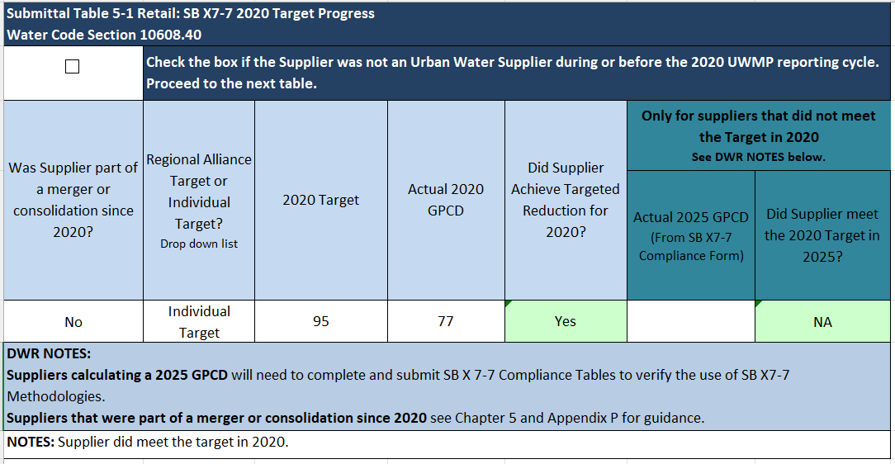

This Page Intentionally Left Blank

GPCD Terminology: Two terms are often used interchangeably; Daily per Capita Water Use and Gallons per Capita per Day (GPCD). Daily per Capita Water Use is the amount of water used per person per day. In the UWMP, this is total water use within a service area, divided by population and is measured in gallons. GPCD is Daily per Capita Water Use measured in gallons. These are different from R-GPCD, which is solely the residential water use divided by population and is used in drought reporting to the State Water Resources Control Board.

