Plan Preparation

Plan preparation
This chapter provides information on the organization, format, and metrics used in the UWMP, along with basic definitions of the retail and wholesale water suppliers that serve the District population. It also outlines some of the processes, including coordination and outreach, that were employed to gather data for the document and provide transparency and inclusion for affected entities and the general public in development of this Plan.
Water Code Section 10620(b) states: Every person that becomes an urban water supplier shall adopt an urban water management plan within one year after it has become an urban water supplier. Crestline Village Water District (CVWD or “District”) is considered an “urban retail water supplier” because it directly provides potable municipal water to more than 3,000 connections. The District is not a “wholesale” supplier. Therefore, the tables and information provided in the subject UWMP follow the requirements for “retail” water suppliers. A checklist to ensure compliance of this Plan with the UWMP Act requirements is provided in Appendix B.
This UWMP follows the chapter organization outlined in the DWR UWMP Guidebook (January 2026) and utilizes data kept and maintained by CVWD, as well as supplemental data from Crestline-Lake Arrowhead Water Agency (CLAWA), Crestline Sanitation District (CSD), and the San Bernardino County Land Use Services Department. The UWMP tables that are required by DWR are included in shades of blue and titled, “Submittal Table 2-1,” for example. The additional tables created during the writing of this report are grey and white and contain letters after the Table number (e.g., “Table 2A”).
Public Water Systems (PWSs) are the systems that provide drinking water for human consumption. These are regulated by the State Water Resources Control Board (SWRCB or State Water Board), Division of Drinking Water (DDW). The PWS name and number, the total number of active connections and volume of water supplied to all CVWD customers as of December 31, 2025, is shown in Submittal Table 2-1.
Submittal Table 2-1: Public Water Systems
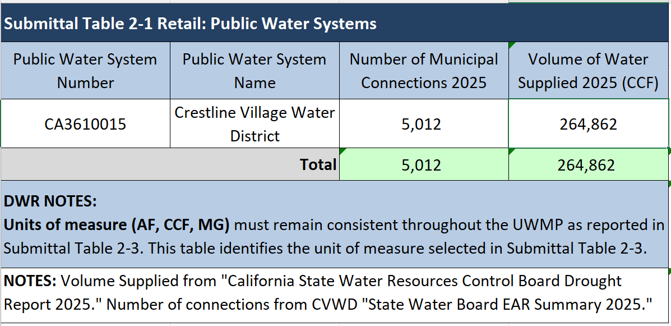
DWR guidelines require the water use and planning data for the entire year of 2025, and because CVWD reports on a calendar year (CY) basis, data included in this UWMP is through December 31, 2025. During CY 2025, CVWD delivered 264,862 hundred cubic feet (CCF) of water to 5,012 active connections (Submittal Table 2-1).
Submittal Tables 2-2 and 2-3 below identify the District as a water retailer and this Plan as an individual UWMP, because the District is an individual water retailer rather than a member of a regional alliance or regional UWMP. Submittal Table 2-2 further indicates the data provided herein is based on CY reporting, with volumes calculated in units of “hundred cubic feet” or CCF.
Submittal Table 2-2: Plan Identification
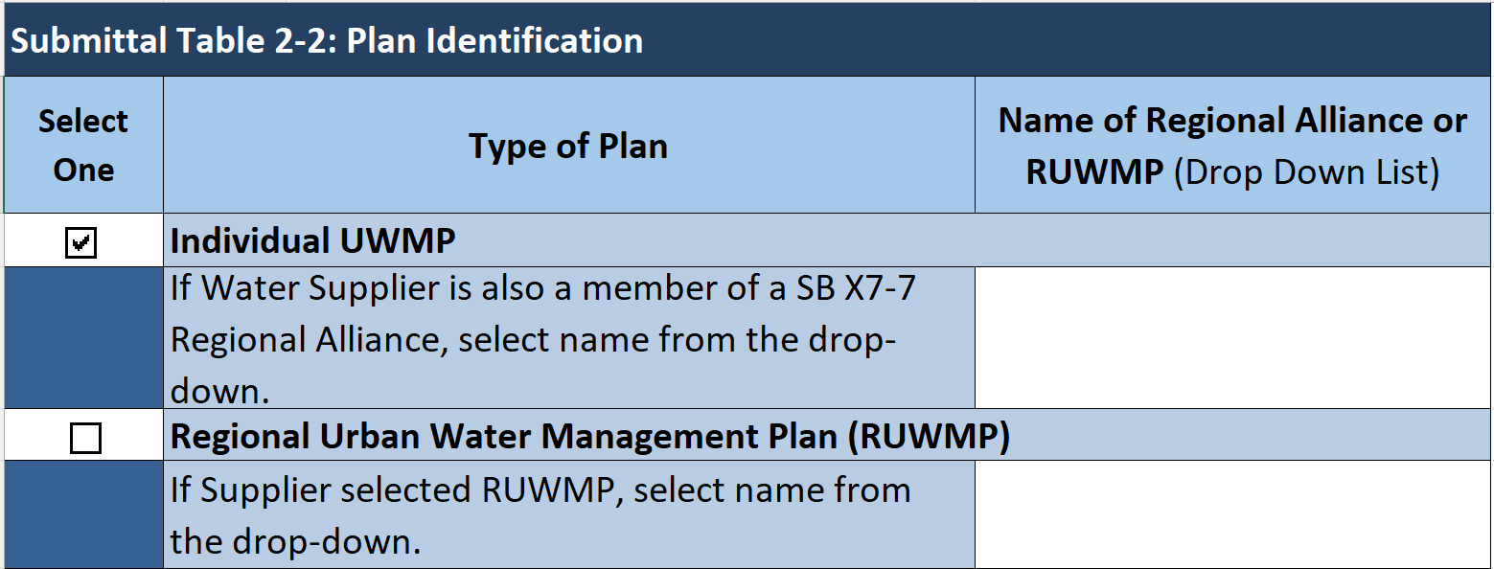
Submittal Table 2-3: Supplier Identification
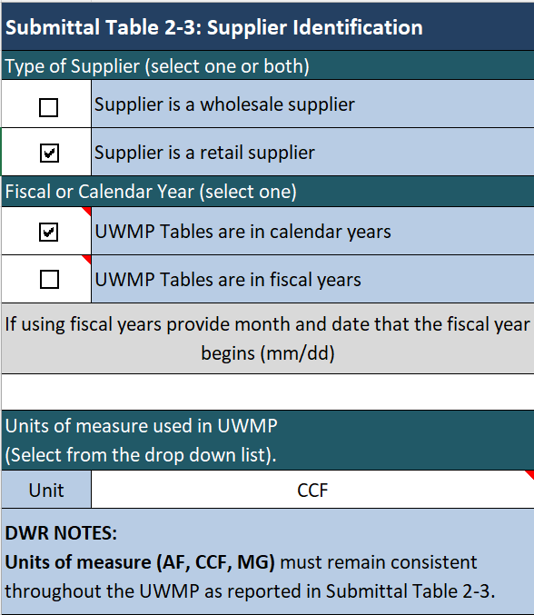

Plan Coordination
Retail agencies, such as CVWD, that receive a water supply from one or more wholesalers, such as CLAWA, are required to coordinate information for the UWMP with their wholesaler(s) and provide their wholesaler(s) with their projected water demand from that source, in five-year increments for 20 years. Submittal Table 2-4 identifies CLAWA as the District’s wholesale supplier and acknowledges that CLAWA has been notified of this Plan.
Submittal Table 2-4: Water Supplier Information Exchange
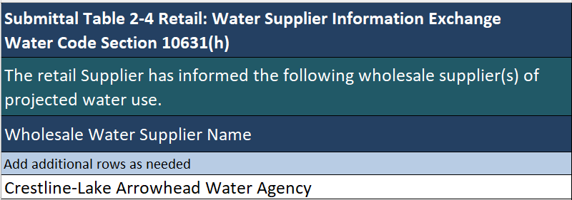
Documentation that CVWD has provided CLAWA with Submittal Table 4-2: Total Uses for Potable and Non-Potable Water - Projected, and Submittal Table 6-9: Water Supplies-Projected to CLAWA on June 5, 2026, is provided in Appendix C.
Since one of the goals of this UWMP, as stated in Chapter 1.2, is to inform CLAWA of the future increases in demand for imported water supplies, CVWD hopes this plan will foster future collaboration with CLAWA and other mountain water suppliers. CVWD has notified and solicited input from the following pertinent agencies for preparation of this Plan:

- Alpine Water Users Association
- Arrowbear Park County Water District
- Cedarpines Park Mutual Water Company
- County of San Bernardino Land Use Services Department
- Crestline-Lake Arrowhead Water Agency
- Crestline/Lake Gregory Chamber of Commerce
- Crestline Sanitation District
- Division of Drinking Water, San Bernardino District
- Lahontan Regional Water Quality Control Board
- Lake Arrowhead Community Services District
- Mojave Water Agency
- Rim of the World Recreation & Park District
- Rim of the World Unified School District
- Running Springs Water District
- San Bernardino County Fire
- Santa Ana Regional Water Quality Control Board
- Santa Ana Watershed Project Authority
- Save Our Forest Association
- Sierra Club, Big Bear Group
- Strawberry Lodge Mutual Water Company
- U.S. Department of Agriculture Forest Service
- Valley of Enchantment Mutual Water Company
- Valley View Park Mutual Water Company

At least 60 days before the public hearing on the Plan, the District is required to notify every city or county to whom they provide water that they are reviewing and considering changes to the Plan. CVWD issued a notification letter to the County and agencies listed above on April 7, 2026, and then issued a second letter on May 12, 2026, which included the exact date, time, and location of the public hearing held on June 16, 2026. The draft UWMP was provided for public review on the CVWD Web site, and a hard copy was posted at the District offices beginning June 1, 2026. Copies of the required letters and public notification in The Alpine Mountaineer and The Mountain News newspapers of the public hearing are included in Appendix D. Chapter 10 includes detailed information regarding notifications and Plan adoption proceedings.

Land Use Agency Coordination
In addition to providing notice to the County of San Bernardino regarding preparation of the 2025 UWMP, CVWD also coordinated with the County’s Land Use Services Department to gather information related to past, current, and future land use in the District area. The San Bernardino County Land Use Services Department was contacted on April 23, 2026, to request current land use information specifically for this UWMP, including, but not limited to, answers to the following questions:
- Is the County preparing for any large-scale projects proposed within the District service area?
- Does the County have information on recent or pending permits for accessory dwelling units (ADUs)?
- Does the County have any other land use-related information that may affect the District’s projections for future water use in the next 20-25 years?
The San Bernardino County Land Use Services Department responded on April 28, 2026, to CVWD with the requested information. Correspondence related to Plan coordination with the San Bernardino County Land Use Services Department may be found in Appendix E.

This Page Intentionally Left Blank

“Person” means any individual, firm, association, organization, partnership, business, trust, corporation, company, public agency, or any agency of such an entity (CWC §10614).

