Water Use Characterization
This chapter describes and quantifies CVWD’s past, current, and projected potable water use by sector through the year 2050, including distribution system water loss, to the extent information is available.

Past and Current Water Use
At approximately 4,600 feet elevation, the CVWD service area, encompassing the unincorporated communities of Crestline and Lake Gregory within the San Bernardino National Forest, has distinct characteristics compared to other water suppliers within Southern California. “Mountain living” and “mountain communities” inherently use water differently from communities in the valleys. Property owners rarely incorporate water-intensive landscaping such as lawns or large manicured frontage features. For the purposes of this UWMP, it is crucial to understand that water conservation is standard practice in this mountain community.
The number of metered connections by sector from CY 2021 to CY 2025 is shown in Table 4A.
Table 4A: Metered Connections by Sector, CY 2021-2025
 | 2021 | 2022 | 2023 | 2024 | 2025 | Average Percent of Total | Average Annual Growth Rate (%)
Single-Family Residential | 4,712 | 4,748 | 4,633 | 4,730 | 4,738 | 95.2% | 0.1%
Multifamily Residential | 54 | 54 | 56 | 57 | 57 | 1.1% | 1.4%
Commercial/  Institutional | 152 | 152 | 203 | 216 | 217 | 3.7% | 9.3%
Total | 4,918 | 4,954 | 4,892 | 4,813 | 5,012 | -- | 0.5%
Source: CVWD Electronic Annual Report to the Drinking Water Program (SWRCB).

The District’s water use by sector from CY 2021 to CY 2025 is shown in Table 4B.
Table 4B: Recorded Water Use by Sector (CCF), 2021-2025
 | 2021^{(a)} | 2022^{(a)} | 2023^{(b)} | 2024^{(b)} | 2025^{(b)}
Single-Family Residential | 232,606 | 214,103 | 204,997 | 213,588 | 207,440
Multifamily Residential | 6,661 | 6,608 | 7,410 | 6535 | 6,887
Commercial/Institutional | 32,999 | 41,025 | 36,542 | 35,171 | 32,031
Other (Hydrant Water) | 88 | - | 285 | - | 5,336
Other (Irrigation) | - | - | - | 411 | -
Total Losses | 32, 897 | 32,220 | 79,343^{(c)} | 23,695 | 13,168
Total (CCF) | 305,251 | 293,956 | 328,577 | 279,400 | 264,862
Units in hundred cubic feet (CCF)
- Source 2021-2022: CVWD Annual Report to the Drinking Water Program (SWRCB) and AWWA Water Audits.
- Source 2023-2025: CVWD Annual Report to the Drinking Water Program (SWRCB); losses for 2023-2025 are estimated as the difference between supply and demand.
- Water loss in CY 2023 increased significantly relative to the other years primarily due to an extraordinary series of storms in February and March that dropped more than 12 feet of snow on the District area, severely restricting access at a time when numerous leaks occurred.

As illustrated in Table 4B, total water demand has decreased gradually during the past five years, most notably in the Single-Family Residential and Commercial/Institutional sectors. Total water usage in 2025 is 15.2 percent lower than total use in 2021. The average annual rate of decrease in total water use from 2021 to 2025 is -3.5 percent. This reflects a pattern of demonstrated water conservation consciousness in the District population and has provided a paradigm for the District in projecting its future water demands.
As of December 31, 2025, CVWD delivered 251,694 CCF (579 AF) of potable water and CY 2025 system losses are estimated at 13,168 CCF for a total of 264,862 CCF (608 AF). The 2020 UWMP projected a total water demand volume of 324,768 CCF for 2025, which means actual water demand in 2025 was 18.5 percent lower than projected for 2025. However, the District met (and considerably surpassed) its 2020 Water Use Target goal for use reduction pursuant to the Water Conservation Act of 2009 (SB X7-7). See Chapter 5 for detailed information. As shown in Submittal Table 4-1, the actual metered water use for CVWD in CY 2025 is divided into five sectors: single-family residential, multifamily residential, commercial/institutional/ Industrial-Fire (hydrant water) and losses. The majority of customer accounts are single-family residential.
Landscape irrigation is not separately metered at any locations. The District does not sell or purchase non-potable or recycled water. System losses from 2021-2024 are reported separately from this discussion in Section 4.3.
Submittal Table 4-1: Total Uses for Potable and Non-Potable Water
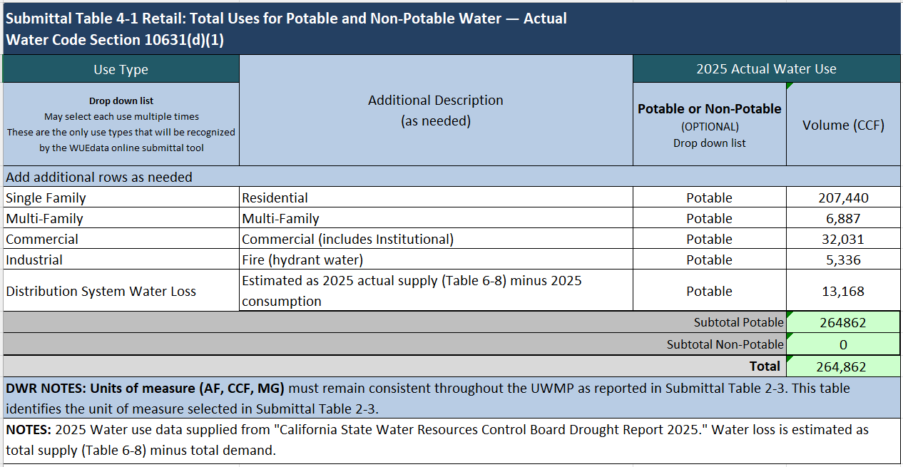

Projected Water Use
To appropriately manage their water supply and plan their infrastructure investments, water agencies must be able to estimate their future water demand as accurately as possible. Factors they must consider are current and future land uses, numbers of dwelling units and their occupants, potential effects of climate change, and typical water demand-generation factors.
As previously mentioned, the mountainous Crestline community has different water use characteristics than those exhibited by typical urban areas in Southern California. The absence of large lots with expansive landscaped areas, the high cost of locally produced water due to its scarcity, and higher pricing of imported water typically combine to create much lower per capita use. Both historically and recently, the population served by CVWD has done an excellent job of conserving water. Many of the conservation measures presented in this Plan are already in effect, following public input and with public support. In other words, much of the water management planning process for CVWD has already taken place through past District actions, with full public involvement and review.
CVWD analyzed its recorded full-time population data and calculated an average annual growth rate of two new residential units per year, or 0.43 percent, which has been applied to the District’s water consumption projections shown below in Submittal Table 4-2. In order to conservatively account for non-residential growth, this percentage was applied across all connection types. Please refer to Submittal Table 3-1 in Chapter 3 for population projections.
Submittal Table 4-2: Total Uses for Potable and Non-Potable Water - Projected
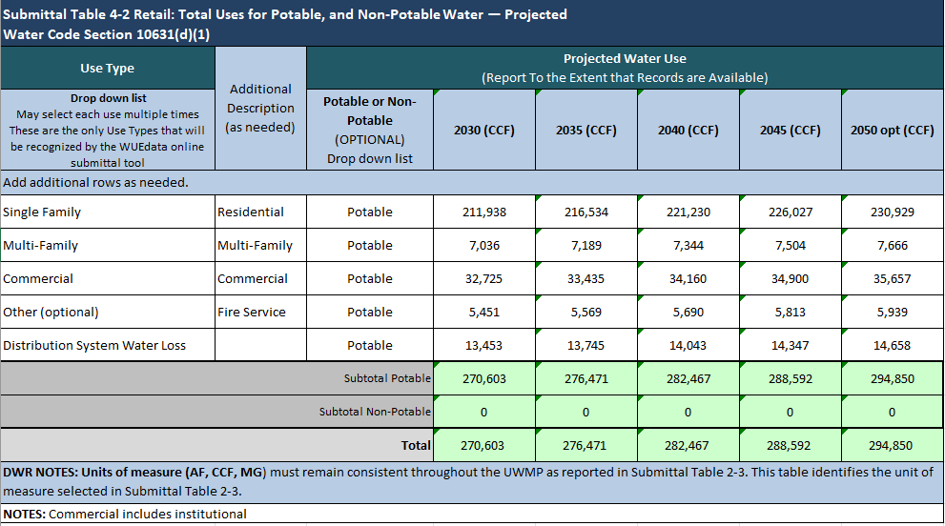
Using this projection methodology, water consumption is projected to increase from 264,862 CCF in 2025 to 294,850 CCF in 2050, an increase of 29,988 CCF or roughly 11 percent. Over the next 25 years, this is an average annual increase of 1,200 CCF. CVWD water demand projections are conservative in that they continue to increase across all land use types. This projection for water demand is for what is considered a “normal” year, rather than a single dry year or one in a succession of multiple dry years. However, as noted before, the Crestline community historically exhibits relatively low per capita water use in comparison with water users in neighboring non-mountain communities. This is not intended to downplay future water demands and subsequent need for more local wells and increased dependency on CLAWA supplies when local well production is limited. Rather, it is intended to only be an accurate reflection of current conditions and for planning purposes.
In its projections of future demand, the District does not include future water savings (or “passive savings”) from codes, standards, ordinances, or transportation and land use plans; nor does it directly consider lower income residential demands in its projections of water use, as noted in Submittal Table 4-3.
Submittal Table 4-3: Inclusion in Water Use Projections
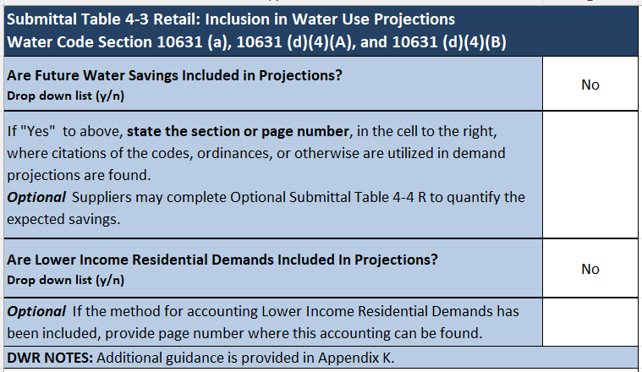

Climate Change Considerations
Beginning with the 2020 UWMP, the Water Code requires the District to consider climate change in its water use projections, which are shown before in Submittal Table 4-2. Considerations for climate change impacts began with using the Climate Change Vulnerability Screening Form for Urban Water Management Planning located in the DWR Guidebook for 2025 UWMPs. Pursuant to Water Code, the District’s planning for climate change impacts was commensurate with the number of customers served and the volume of water supplied. The type and degree to which climate change impacts were considered in the District’s water use projections, and the basis for those assumptions are described below.
As described in Chapter 3, Western Municipal Water District (Western) prepared a Technical Memorandum dated Sept. 6, 2022 describing an analysis performed as part of its final 2022 Drought Contingency Plan and Climate Change Vulnerability Assessment (WMWD(a)). A copy of the 57-page memorandum is located in Appendix G. The results of the analysis included factors that reflect the trends in rainfall and temperature expected from an average of many climate change models. The trends are commensurate with the Cal-Adapt projections for Crestline. If applied to water supply and demand projections, the factors can illustrate the projected effects of climate change to supply and demand within Western’s service area. Although Western’s service area does not include CVWD, it does include much of the neighboring Inland Empire valley region. Because CVWD is located at a much higher elevation than Western’s service area, it receives more precipitation and has less outdoor water use than what would be expected in the valley; therefore, the factors reflect conservative assumptions for the CVWD service area. CVWD has used these factors herein where noted (see Table 4C). The results of the analysis that pertain to water demands are provided below:
The impacts of climate change on outdoor water demand are projected to be similar during normal and drought years over the next two decades. This is because climate change datasets show that temperatures are projected to increase over time, regardless of hydrologic conditions. These projected increases in temperature are estimated to increase ET rates for landscaping, irrigated agriculture, and native vegetation. For all year types, outdoor water use is projected to increase by about 3 percent during the next two decades. The water demand change factors are applied to outdoor water uses, which have been adjusted for future population growth and conservation measures. Indoor water uses are assumed to respond to future population growth and conservation as well but are not sensitive to climate change. (WMWD(a), p. 13)
Therefore, because of the relatively low water demand for landscaping, the absence of irrigated agriculture and prevalent use of native vegetation, climate change effects on water demand are not expected to be significant in the CVWD service area.
Table 4C: Water Demand Change Factors for Outdoor Water Uses
Beginning Year | Normal Year | Single-Dry Year | Five-Year Dry Period
2025 | 100.7% | 100.6% | 100.7%
2030 | 101.4% | 100.9% | 101.5%
2035 | 102.0% | 101.9% | 102.1%
2040 | 102.2% | 102.6% | 102.8%
2045 | 103.4% | 103.3% | 103.5%
Source: Western Municipal Water District, Technical Memorandum: Western Drought Contingency Plan – Climate Change Vulnerability Assessment, September 6, 2022 (WMWD), Table A11, Median Scenario).

To account for the potential effects of climate change to water demands, and the uncertainty therein, CVWD has conservatively applied the normal year factors from Western’s analysis in Table 4C to the demand projections of Submittal Table 4-2 beginning in 2025 through 2045, even though some of CVWD demand is indoor use that is not sensitive to climate change. The results are shown below in Table 4D.
Table 4D: Potential Effect of Climate Change to Projected Demands
 | 2025 | 2030 | 2035 | 2040 | 2045
Total Demands (CCF)⁽¹⁾ | 264,862 | 270,603 | 276,471 | 282,467 | 288,592
Water Demand Climate Change Factor⁽²⁾ | 100.7% | 101.4% | 102.0% | 102.2% | 103.4
Total Demands with Climate Change Factor (CCF) | 266,716 | 274,391 | 282,000 | 288,681 | 298,404
Potential Increase in Water Demand from Climate Change (CCF) | +1,854 | +3,788 | +5,529 | +6,214 | +9,812
Notes: Units in hundred cubic feet (CCF).
(1) From Submittal Table 4-2.
(2) Normal Year Climate change factors from Table 4C (WMWD).
According to Cal-Adapt and Western’s technical memorandum and climate change analysis, higher temperatures and less rainfall are anticipated to occur as a result of climate change, and these are the factors that may affect water demand the most. Customer demands increase in summer; therefore, an increase in average annual temperatures and the frequency and duration of heat waves as the result of climate change is expected to increase existing customer demands for water, particularly outdoor use.
As of 2025, the District does not serve any industrial or agricultural end users, whose water use might be significantly affected by higher temperatures, nor does it sell water to other agencies, which might experience increases in demand. The mountainous Crestline community has different water use characteristics from those exhibited by typical urban areas in that outdoor water usage is minimal. For example, large lots with expansive landscaped areas are nonexistent, so significant increases in landscape irrigation in response to extended drought conditions caused by climate change are not anticipated. Further, the District does not supply water for saline water intrusion barriers, groundwater recharge, conjunctive use, exchanges, surface water augmentation, transfers, or wetlands/wildlife habitat, which are all uses that could be affected by higher temperatures and drought as a result of climate change.

Distribution System Water Losses
Distribution system water losses include “apparent” losses and “real” losses. Apparent water loss includes water theft, metering inaccuracies, and data handling errors. Real losses are the physical water losses from the water distribution system and the supplier’s storage facilities, up to the point of customer consumption. Real losses can occur because of leaking or broken pipes, leaks or overflows at storage tanks, or leaks at service connections.
California Senate Bill No. 1420 (SB 1420) requires water utilities that submit UWMPs to calculate annual system water losses using the water audit methodology developed by the American Water Works Association (AWWA). SB 1420 also requires that utilities submit these annual audits every five years as part of their respective UWMP. To facilitate user-friendly and consistent water auditing practices, AWWA has developed the AWWA Free Water Audit Software, which is based on the principles of the AWWA M36 Water Audit methodology. Per DWR guidelines, utilities must use this software to complete their audit. Losses from CY 2025 are estimated as the difference between total production and consumption because the 2025 AWWA Water Audit was not due until after this report was completed. The losses from CY 2020 through 2022 are from the District’s validated water loss audits. The losses from CY 2023 and 2024 are also estimated as the difference between production and consumption because CVWD submitted their water loss audits, but then was asked to resubmit them and they were still under review at the time this report was completed and submitted as shown in Submittal Table 4-5. The complete audits from CY 2020 through 2022 may be found in Appendix H.
Submittal Table 4-4: Water Loss Audit Reporting
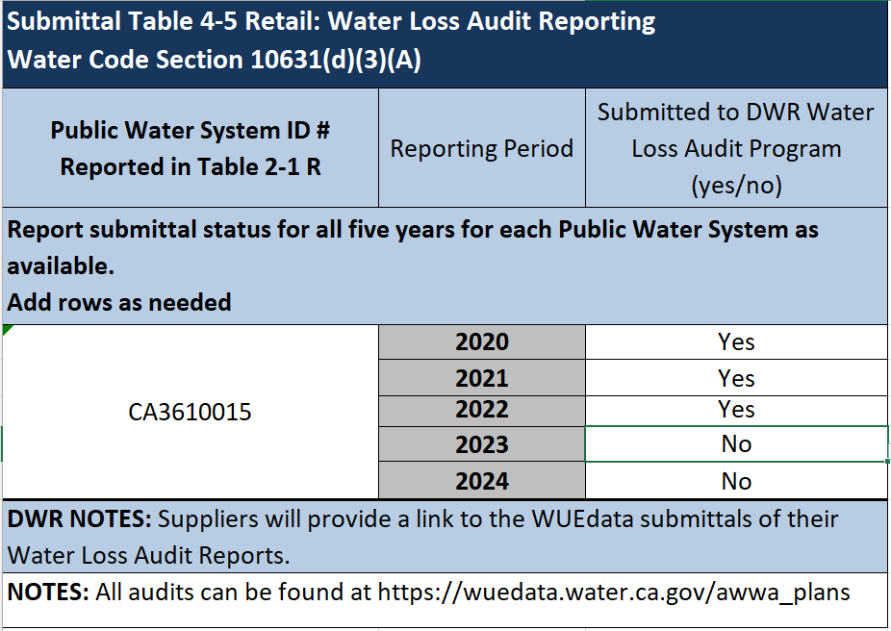

The water audits performed on the CVWD data considered the water supplied, the water consumed, pipeline system details, and cost data to arrive at a “Water Audit Data Validity Score” on a 100-point scale. For CY 2020 and 2021, the completed audits showed the District at scores of 46 and 45, respectively, out of 100. Those scores put CVWD’s water audit data within “Level II” on a five-level rating scale. DWR provided suggestions for data improvement for each Level to control water loss in five focus areas, as shown below for Level II in Table 4E. In CY 2022, the District improved considerably on the Water Audit Validity Score due to improvements to the system, putting CVWD’s water audit data within Level IV. Suggestions for improvement in Level IV are shown in Table 4F.
Table 4E: DWR Water Loss Control Recommendations Level II
 | Audit Data Collection | Short-Term Loss Control | Long-Term Loss Control | Target-Setting | Benchmarking
Level II  (score 26-50) | Analyze business process for customer metering and billing functions and water supply operations, identify data gaps, improve supply metering | Conduct loss assessment investigations on a sample portion of the system: customer meter testing, leak survey, unauthorized consumption, etc. | Begin to assess long-term needs requiring long-term expenditure: customer meter replacement, water main replacement program, new customer billing system or AMR/AMI system. | No comment | No comment.

Table 4E: DWR Water Loss Control Recommendations Level IV
 | Audit Data Collection | Short-Term Loss Control | Long-Term Loss Control | Target-Setting | Benchmarking
Level IV  (score 71-90) | Refine data collection practices and establish as routine business practices. | Refine, enhance or expand ongoing programs based upon economic justification. | Conduct detailed planning, budgeting and launch of comprehensive improvements for metering, billing, or infrastructure management | Establish mid-range (5-year horizon) apparent and real loss reduction goals. | Performance Benchmarking with Pls is meaningful in comparing real loss standing.

According to District records, the system loss for the past 37 years of data has been less than 9 percent, on average. For the past 28 years, system loss has been kept at an average of 6 percent of total supply (CVWD Annual Sources of Supply/System Loss/Rainfall spreadsheet).

Progress Toward Meeting the Water Loss Performance Standard
Pursuant to Water Code section 10631(d)(3)(C), CVWD is required to provide data demonstrating whether it met the water loss performance standard adopted by the State Water Resources Control Board. Pursuant to this law, urban retail water suppliers have submitted annual water loss audits to DWR since October 2017. (Copies of validated water audits for the past five years are located in Appendix I and summarized in Submittal Table 4-5 shown above.) Based on the annual water loss audits submitted from 2017 to 2020, a water loss standard for each urban retail water supplier was developed through a rulemaking by the State Water Resources Control Board that became effective in 2023.
CVWD’s real water loss standard is 6.0 gallons per service connection per day (GPSCD).
CVWD will be required to meet its water loss standard shown in Submittal Table 4-6 by January 1, 2028 (or by 2031 in some cases), using annual water audit data submitted for 2025, 2026, or 2027. Ongoing compliance will be on a three-year average basis.
Submittal Table 4-5: Progress Toward 2028 Water Loss Standard
Insert here
Even though the real water loss standard does not have to be met until 2028, Water Code still requires this UWMP to contain data showing whether it was met. Therefore, to demonstrate that CVWD is expected to meet its water loss standard, refer to Submittal Table 4-6 that shows the District reported in its most recent AWWA water loss audit (CY 2022) a real water loss of 11.6 per unit per day and apparent water loss of 1.7 per unit per day that DID exceed the District’s 2028 real water loss standard of 6.0 per unit per day but did NOT exceed the 2028 apparent water loss standard of 2.7 per unit per day.

This Page Intentionally Left Blank

The terms “water use” and “water demand” are used interchangeably in the UWMP per DWR guidelines.
The AWWA Water Audit provides another performance indicator in addition to the Data Validity Score called the Infrastructure Leakage Index (ILI). However, the ILI is not discussed here since the Water Audit manual located in the DWR Guidebook, Appendix L, advises not to use the ILI for small systems or those that operate at low pressure.
Standard released by SWRCB December 8, 2025 (https://www.waterboards.ca.gov/conservation/docs/waterlosscontrol/standards-released.xlsx). The standard can be adjusted by a water supplier if data becomes available to support the change.

