System Description

General Description
The Crestline and Lake Gregory communities in unincorporated San Bernardino County, California, receive their domestic water service from Crestline Village Water District (CVWD). Crestline is located about 10 miles north of the City of San Bernardino in the San Bernardino Mountains, where most of the land surrounding the community is within the Mountaintop Ranger District of the San Bernardino National Forest. Crestline and its neighboring mountain communities occupy islands of private land surrounded by National Forest lands. Located along the crest of the San Bernardino Mountains and in adjacent valleys high on the mountains' north slopes, the terrain in the CVWD service area is rugged, with moderate-to-steep slopes and elevations ranging from about 4,000 feet to over 5,600 feet. The elevation at Lake Gregory, located at roughly the center of the District, is 4,550 feet (USGS datum). Unlike Southern California's valleys, the mountains experience a four-season climate. The District’s service area lies predominantly on the north side of State Highway 18 (Rim of the World Drive) and is served by State Highways 138 and 18.
On January 19, 1954, the citizens of Crestline organized CVWD under the authority of the County Water District Law (Water Code Sections 31000, et seq.). CVWD was originally known as the Crestline Village County Water District and served only the immediate Crestline area, with approximately 1,600 service connections. For nearly two decades, all of CVWD’s water supplies were from local sources until Crestline-Lake Arrowhead Water Agency (CLAWA) began delivering imported water in 1972. Since then, CVWD has been able to rely on a combination of local and imported water supplies to meet demand. The area served by CVWD has grown over the years, as additional land has been annexed. The largest change occurred on October 1, 1979, when CVWD acquired the facilities of the Lake Gregory Water Company (LGWC) and accepted responsibility for providing retail water service in the area immediately surrounding the lake. By acquiring the LGWC, the District almost doubled in size.
As a public agency, CVWD has an elected five-person Board of Directors that serves as its legislative governing body with responsibility for developing and implementing laws that govern the community services provided within its jurisdiction. Each of the five board members is elected to four-year terms by registered voters who reside within the CVWD service territory. The Board of Directors conducts public meetings on the 3rd Tuesday of each month at the CVWD office located at 777 Cottonwood Drive in Crestline.

Service Area Boundary
The CVWD service area includes the mountain communities of Crestline and Lake Gregory, covering 2,840 acres (4.4 square miles) of unincorporated San Bernardino County. Refer to Figures 1-1, 1-2, and 1-3 for vicinity maps. The District’s service area is generally bounded by Highway 18 and the south face of the San Bernardino Mountains to the south, the community surrounding Lake Arrowhead to the east, very rural National Forest land to the west and generally uninhabited north slope of the mountains and start of the ‘high desert’ to the north. The service area generally surrounds Lake Gregory and its surrounding community.
CVWD’s Sphere of Influence is determined by the Local Agency Formation Commission of San Bernardino County (LAFCO) and is shown on Figure 3-1 – Sphere of Influence. A Sphere of Influence is defined as, “A plan for the probable physical boundaries and service area of a local agency, as determined by the commission.” The CVWD Sphere of Influence covers approximately 12 square miles and encompasses the CVWD service area. The most recent update to the Sphere of Influence for CVWD was adopted January 19, 2011. Although designation of a Sphere of Influence is a legal requirement for public agency water suppliers, it does not affect pre-existing service arrangements by others within the sphere. Also, inclusion in the Sphere of Influence does not mean that land will inevitably become annexed to CVWD. CVWD may consider annexing property into its service area only if requested by the property owner. The District is not actively pursuing any annexations at this time.
As shown on Figure 3-2 – National Forest Boundary, there are three non-contiguous portions of the CVWD service area, as described from west to east: first, an isolated residential area called Stewart Ranch; second, the Valley of Enchantment Elementary School, and third, an isolated residential area just north of Thousand Pines Christian Camp. Each of the non-contiguous areas in the service area was served previously by private wells or small mutual water companies that could not continue service and asked CVWD to annex them into the District service area. The land immediately outside the service area are served by either private wells or small mutual water companies.
CVWD produced water locally from 35 wells located on 22 individual sites in 2025. There are currently 11 inactive wells. When local well production does not meet demand, CVWD purchases supplemental water supply from CLAWA, which is the State Water Project (SWP) contractor and water wholesaler to the San Bernardino Mountains area. CVWD has eight connections to the CLAWA water system at several different locations in the system; therefore, customers may receive a mixture of well and imported water, just well water or just imported water.
Supplemental water purchased from CLAWA has been treated at CLAWA's water treatment facility at Silverwood Lake. Water produced locally from CVWD's wells meets applicable drinking water standards and does not require treatment, other than chlorination of some wells. CVWD chlorinates water from its Pioneer, Horst, Wilson, and wells and monitors water quality at all wells. The District's existing Chamois and Electra wells show elevated levels of gross alpha radiation, which is a treatable type of energy released when radioactive elements from naturally occurring uranium in the rocks decay or break down, and they are treated through a separate, onsite process. Thus, the District operates no centralized, complete water treatment facilities of its own.
As of 2025, the District has 14 water storage tanks at 12 locations, with a total storage capacity of 8.644 million gallons (11,555 CCF). Pumping and pressure-reducing facilities are used where needed. The distribution system has 11 water pressure zones in one contiguous area, 13 pump stations and approximately 73 miles of pipelines moving water through the system. A schematic plan of CVWD's water system and a pressure zone map are provided in Appendix F. The system contains many miles of pipelines of varying ages, types, and conditions.
3.2.1 Annexations
There have been no annexations, consolidations, or other changes to the service area since the 2020 UWMP. In the 2020 UWMP, CVWD reported that studies and consideration were underway for possibly annexing Valley View Park Mutual Water Company (VVPMWC), a small water retailer located within the District’s sphere of influence. Since that time, CVWD declined to pursue the annexation.

Service Area Climate
When considering the analysis in this section and in the “Climate Change Considerations” section that follows, it is important to differentiate between the terms, “weather” and “climate.” Weather is defined as how the atmosphere behaves over short periods, (i.e., days and weeks), while climate refers to how the atmosphere behaves over the long term. When looking at climate and long-term potential effects of climate change, we consider averages of temperature, rainfall, snowfall water equivalent, humidity, evaporation, and other metrics over a period of years and decades.
The mountainous climate of the CVWD service area is generally cooler than the surrounding lower elevations. As shown on proceeding tables, summers are dry with average temperatures as high as 81°F, and winters are wet and cool, with average temperatures as low as 25°F. The average evapotranspiration rate (ET_{o}), maximum and minimum temperature data and rainfall data gathered from the Lake Arrowhead CIMIS (California Irrigation Management Information System) station for years 2005 (the year after the station was established) through 2025 are provided in Table 3A.

Table 3A: Evapotranspiration, Temperature and Precipitation Data
for the District Service Area, 2005-2025
 | Jan | Feb | Mar | Apr | May | Jun | Jul | Aug | Sep | Oct | Nov | Dec
Standard Monthly Average ET_{o} (inches) | 1.7 | 2.2 | 3.6 | 5.0 | 6.2 | 7.2 | 7.5 | 7.0 | 5.2 | 3.7 | 2.4 | 1.6
Average Max. Temperature (°F) | 50 | 51 | 54 | 60 | 67 | 75 | 81 | 80 | 76 | 67 | 58 | 51
Average Min. Temperature (°F) | 26 | 26 | 30 | 33 | 37 | 42 | 49 | 48 | 43 | 35 | 29 | 25
Average Total Precipitation (inches) | 3.7 | 3.1 | 2.7 | 1.5 | 0.8 | 0.5 | 0.5 | 0.4 | 0.6 | 0.8 | 1.6 | 3.6 | 19.9
Source: CIMIS Station 192 Lake Arrowhead-San Bernardino (http://www.cimis.water.ca.gov/Default.aspx

As shown in Table 3A, the average annual rainfall from 2005 to 2025 totaled approximately 20 inches. The average monthly snowfall data from the National Oceanic and Atmospheric Administration (NOAA) Crestline weather station from 2010 to 2015 are presented in Table 3B. The average annual snowfall was approximately 12 inches. (Reporting of snowfall data for the years 2016 through 2025 from this station and other local stations contains considerable gaps in data, therefore only the most recent full six-year data is presented here.)
Table 3B: Average Monthly Snowfall for the District Service Area, 2010-2015
 | Jan | Feb | Mar | Apr | May | Jun | Jul | Aug | Sept | Oct | Nov | Dec | Total
Average Total Snowfall¹ (inches) | 4.0 | 4.5 | 2.1 | 0.3 | 0.0 | 0.0 | 0.0 | 0.0 | 0.0 | 0.0 | 0.0 | 1.3 | 12.2
Source: NOAA National Environmental Satellite, Data, and Information Service. https://www.ncei.noaa.gov/access/past-weather/34.6703354,-117.5580464,34.1703354,-117.0580464 Station: CRESTLINE 0.2 WSW, CA US GHCND:US1CASR0019. Values in table represent rounded averages, thus, values reported as zero may not actually be equal to zero.
¹ Snowfall: Maximum amount of new snow that has fallen since the previous observation.

The entire State, and in particular Southern California recently experienced a severe multi-year drought, so for comparison the recorded average rainfall and snowfall amounts from the Western Regional Climate Center (WRCC) are also provided in Table 3C, below. These recorded average values represent averages from 1941 through 2011 at Lake Arrowhead, which is located nearly five miles to the east but maintains approximately the same elevation and geographic position on the mountain ridge (data from 2012-2025 is not available from this station).
Table 3C: Recorded Monthly Rain and Snowfall Data
for the District Service Area, 1941-2011
 | Jan | Feb | Mar | Apr | May | Jun | Jul | Aug | Sep | Oct | Nov | Dec | Total
Recorded Average Total Precipitation (inches) | 8.6 | 7.9 | 6.5 | 2.9 | 1.1 | 0.2 | 0.1 | 0.4 | 0.8 | 1.6 | 4.2 | 5.7 | 40
Recorded Average Total Snowfall (inches) | 10.8 | 11.4 | 11.7 | 5.1 | 0.8 | 0.0 | 0.0 | 0.0 | 0.0 | 0.2 | 2.1 | 5.6 | 47.7
Source: WRCC Station 044671, Lake Arrowhead, CA. (http://www.wrcc.dri.edu.)
(This station’s period of record only contains the years 1941 through 2011.)

Average rainfall and snowfall from the past 15 years compared to recorded averages illustrate recent drought conditions, with less than half the rain and snow received. The annual rainfall and, in particular, the snowfall has a great influence on well production in a fractured bedrock aquifer. With the changing climate there are also anomalies, such as the winter of 2022-2023, when the CVWD service area received more than 12 feet of snow, creating many perennial seep springs where they were usually seasonal, and some of those flowed for two years or more.

Summary of Climate Change Considerations
Water Code now requires water suppliers to account for how climate change might impact water supplies and the reliability of those supplies. Although the Water Code has recommended sources and guidance for addressing climate change, it does not require specific methods for considering this issue in the UWMP. We address climate change in several appropriate sections, including here, where we describe potential climate change effects in the District service area. The other sections in which the effects and considerations of climate change will be addressed include Chapter 4 (Water Use Characterization), Chapter 6 (Water Supply Characterization), and Chapter 7 (Water Service Reliability and Drought Risk Assessment).
Measures the District has taken over the past decade to improve resilience and reduce vulnerabilities to potential effects of climate change include increasing storage capacity, implementing conservation programs, taking steps to prevent fire damage to facilities, and ensuring backup energy supply and onsite energy generation. The District also has ongoing processes for enhancing its water quality monitoring program, drilling new wells, and modifying existing wells to enhance local water supply.
The analysis of climate change considerations throughout this document is guided in part by the “Urban Water Management Plan Guidebook 2025” and partly relies, as recommended in the Guidebook, on the tools and resources available on the Cal-Adapt Website (https://cal-adapt.org/), which synthesizes volumes of downscaled climate change projections and climate impact research from California's scientific community (https://v2.cal-adapt.org/tools/local-climate-change-snapshot/).
The Cal-Adapt model data should not be considered as predictions of how the weather will behave on a certain future date, or when heavy snowfall, heat waves, low rainfall, or other events will occur. The data, however, can tell us how much more often or less often we could expect these events to occur in the future.
The Cal-Adapt models presented below include predictions for the period of 2006 to 2100 and provide modeled recorded values from 1950 through 2005. Two climate change scenarios form the basis for these projections—medium and high greenhouse gas emissions. Called Representative Concentration Pathways (RCPs), each represents standard assumptions for the medium and high greenhouse gas aerosol emissions scenarios. In RCP 4.5 (the medium-emissions scenario) global carbon dioxide (CO₂) emissions peak by 2040 and then start to decline. In this scenario, statewide average temperature is expected to increase 2-4 Celsius (°C) by the year 2100 (3.6-7.2 degrees Fahrenheit [°F]). In RCP 8.5 (the high-emissions scenario) global carbon dioxide (CO₂) emissions continue to rise throughout this entire century. In this scenario, the statewide average temperature expected to increase 4-7°C for this scenario by the year 2100 (7.2-12.6°F). Cal-Adapt does not provide a low emissions scenario.
Cal-Adapt’s “Local Climate Change Snapshot” tool provides the following climate projections for temperature, precipitation, and wildfire for the District’s service area. A location on Zurich Drive in Crestline was selected as the representative location in the middle of the District’s service area. The main climate change-related concerns in the District area for supply and demand, according to Cal-Adapt data, are drought, groundwater depletion, reliance on water diverted from the San Joaquin Delta, peak demand volume surges from extreme heat or temperature trends, and increased risk of fire.
Pursuant to Water Code, the District’s level of analysis of the potential effects of climate change on its supplies and demands has been done at a level commensurate with the size of the distribution system. Because of its size and analytical resources, CVWD looked to Western Municipal Water District (WMWD or Western), a large wholesale and retail water supplier in adjacent Western Riverside County with a service area of 527 square miles. Western was able to conduct a comprehensive analysis of a large array of climate change models as part of its 2022 Regional Drought Contingency Plan (WMWD(a)). A copy of Western’s Climate Change Vulnerability Assessment is provided in Appendix G. Their source data was climate models gathered by DWR for water resources planning. Although Western’s service area does not include the San Bernardino Mountains, the trends they identified in future effects to water supply and demand from climate change are commensurate with the summary of anticipated climate changes from Cal-Adapt for the Crestline area provided below. Those trends from Cal-Adapt of increasing temperatures and decreasing rainfall do not conflict with Western’s analysis. Therefore, the climate change factors from Western’s analysis are used here in Chapter 4 and in Chapter 6 to account for climate change effects to CVWD’s water supply and demand projections.

Cal-Adapt Temperature Projections
Generally, over the course of the 21st Century, temperatures throughout the state are projected to rise. Still, local impacts will vary greatly. Four separate climate indicators are reported by Cal-Adapt for temperature changes: Annual Average Maximum Temperature, Annual Average Minimum Temperature, Extreme Heat Days, and Warm Nights.
Annual Average Maximum Temperature reports the average of all the hottest daily temperatures in a year. Shown on Chart 3-1 is the most likely outcome and range of future projections of Annual Average Maximum Temperature in the District area.
Chart 3-1 – Cal-Adapt Projections for Annual Average Maximum Temperature (°F)
(Source: Cal-Adapt, Local Climate Snapshot for Crestline)
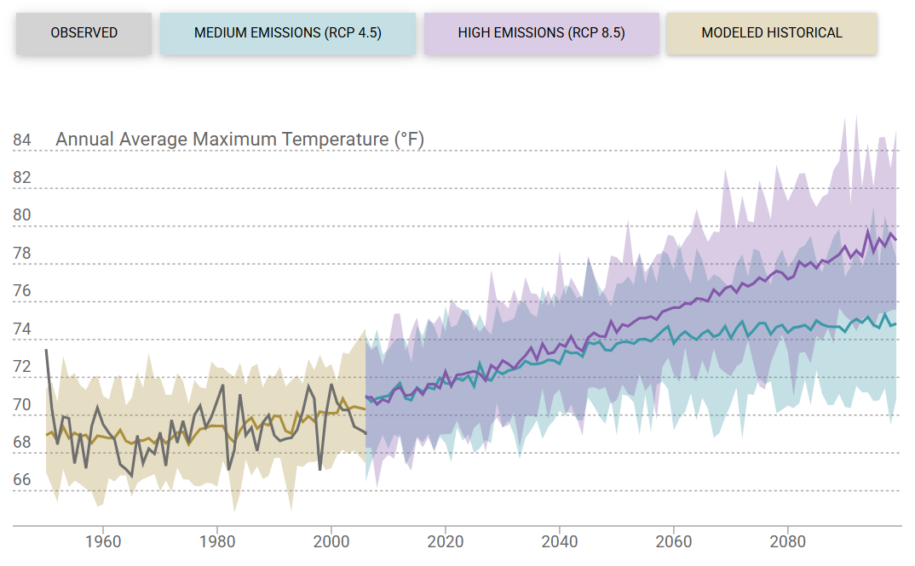

Cal-Adapt baseline and mid-century projections for Annual Average Maximum Temperature are summarized in Table 3D below. This is the average of all the hottest daily high temperatures in a year.
Table 3D: Annual Average Maximum Temperature (Cal-Adapt Projections)
Time Period | Change from Baseline | 30-Year Average | 30-Year Range
Baseline (1961-1990) | -- | 69.0 °F | 68.7 – 69.5 °F
Mid-century (2035-2064)
RCP 4.5 | +4.6 °F | 73.6 °F | 71.3 – 76.1 °F
RCP 8.5 | +5.6 °F | 74.6 °F | 72.0 – 76.8 °F
Source: Cal-Adapt, Local Climate Snapshot for Crestline. From California’s Fourth Climate Change Assessment.
RCP: representative concentration pathway; 4.5: medium emissions scenario; 8.5: high emissions scenario.
Annual Average Minimum Temperature reports the average of all the coldest daily temperatures in a year, shown on Chart 3-2 is the most likely outcome and range of future projections of Annual Average Minimum Temperature in the Crestline area.
Chart 3-2– Cal-Adapt Projections for Annual Average Minimum Temperature (°F)
(Source: Cal-Adapt, Local Climate Snapshot for Crestline)
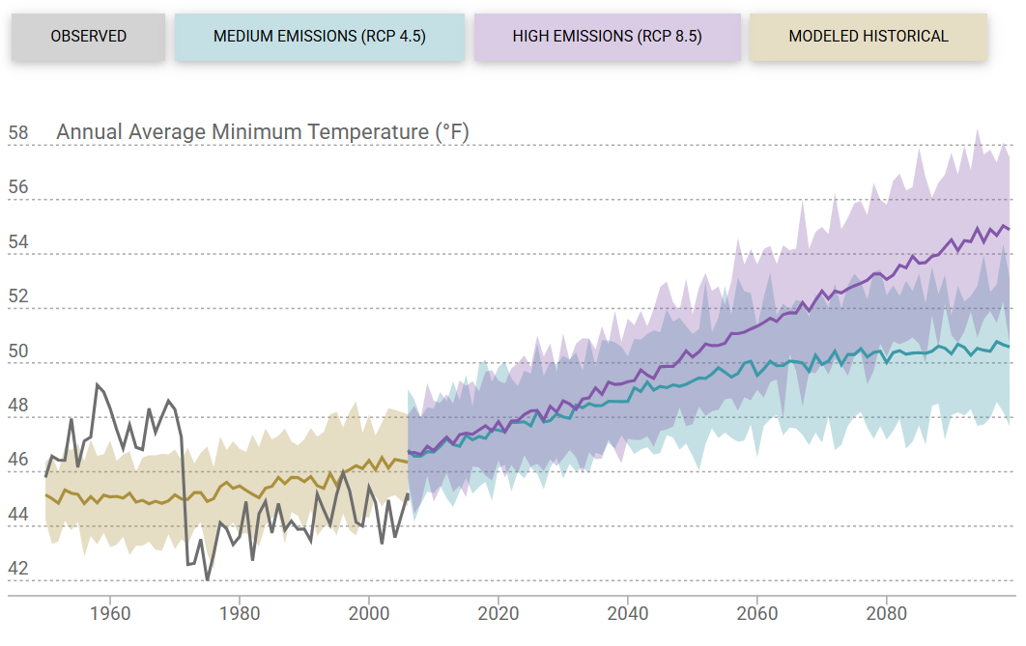
Table 3E below summarizes Cal-Adapt baseline (1961-1990) and mid-century projections (2035-2064) for Annual Average Minimum Temperature in the Crestline area.
Table 3E: Annual Average Minimum Temperature (Cal-Adapt Projections)
Time Period | Change from Baseline | 30-Year Average | 30-year Range
Baseline (1961-1990) | -- | 45.2 °F | 45.1 – 45.4 °F
Mid-century (2035-2064)
RCP 4.5 | +4.1 °F | 49.3 °F | 47.7 – 50.6 °F
RCP 8.5 | +5.1 °F | 50.3 °F | 48.4 – 51.7 °F
Source: Cal-Adapt, Local Climate Snapshot for Crestline. From California’s Fourth Climate Change Assessment.
RCP: representative concentration pathway; 4.5: medium emissions scenario; 8.5: high emissions scenario.
Extreme Heat Days reflects the number of days in a year when daily maximum temperature is above a threshold temperature of 95.1 °F. Chart 3-3 shows the most likely outcome and range of future projections of Extreme Heat Days in the Crestline area.
Chart 3-3 – Cal-Adapt Projections for Number of Extreme Heat Days
(Source: Cal-Adapt, Local Climate Snapshot for Crestline)
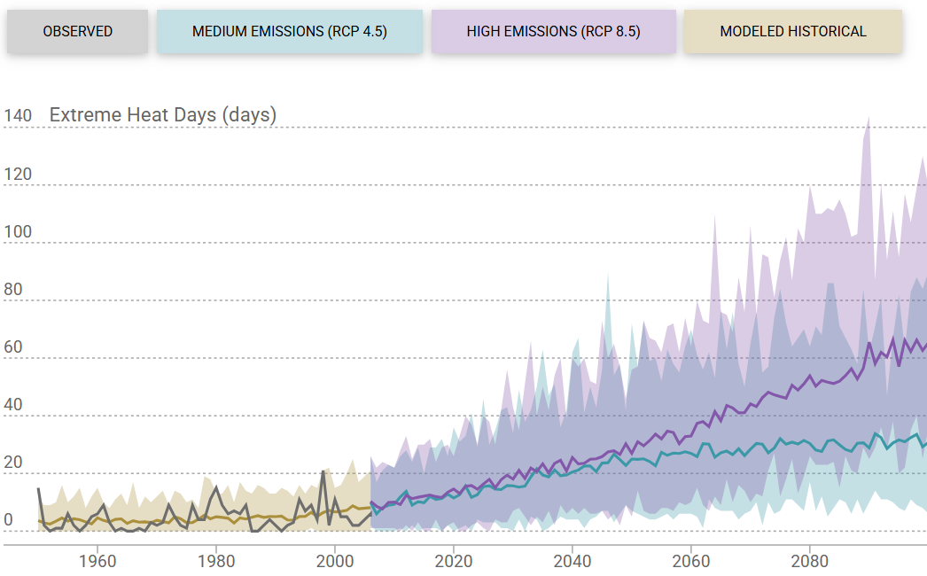
Cal-Adapt projections of Extreme Heat days for baseline (1961-1990) and mid-century (2035-2064) time periods in the District area are summarized below in Table 3F.
Table 3F: Extreme Heat Days (Cal-Adapt Projections)
Time Period | Change from Baseline | 30-Year Average | 30-year Range
Baseline (1961-1990) | -- | 4 days | 3 – 5 days
Mid-century (2035-2064)
RCP 4.5 | +20 days | 24 days | 13 – 54 days
RCP 8.5 | +25 days | 29 days | 16 – 58 days
Source: Cal-Adapt, Local Climate Snapshot for Crestline. From California’s Fourth Climate Change Assessment.
RCP: representative concentration pathway; 4.5: medium emissions scenario; 8.5: high emissions scenario.
Warm Nights reports the number of days in a year when daily minimum temperature is above a threshold temperature of 68.5 °F. Chart 3-4 shows the most likely outcome and range of future projections of Warm Nights in the CVWD area.
Chart 3-4 – Cal-Adapt Projections for Number of Warm Nights
(Source: Cal-Adapt, Local Climate Snapshot for Crestline)
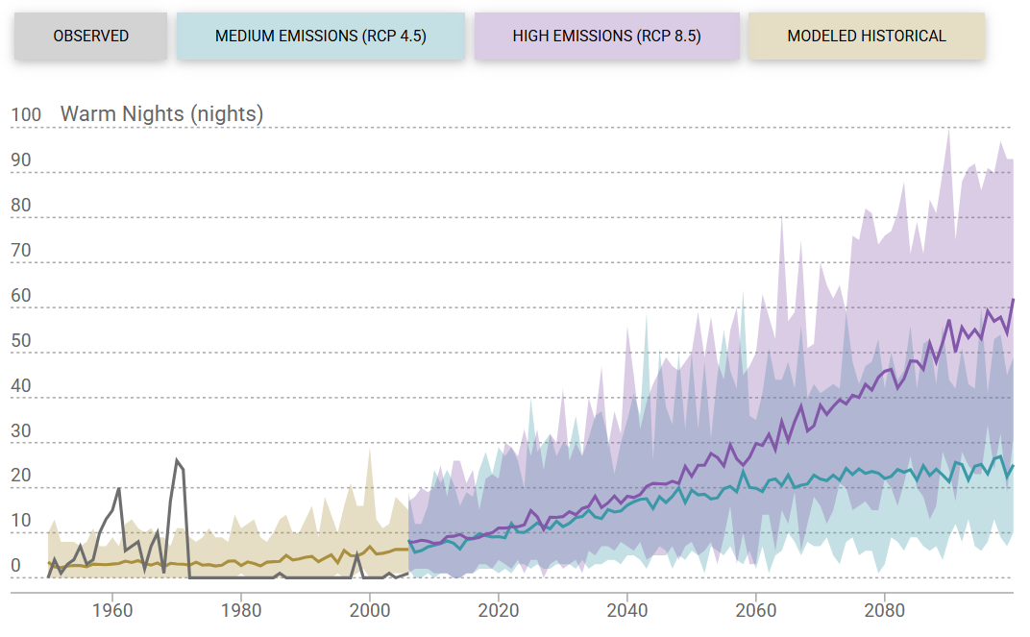
Table 3G below summarizes Cal-Adapt baseline and mid-century projections for Warm Nights, for baseline (1961-1990) and mid-century (2035-2064) time periods in the Crestline area.
Table 3G: Warm Nights (Cal-Adapt Projections)
Time Period | Change from Baseline | 30-Year Average | 30-year Range
Baseline (1961-1990) | -- | 3 nights | 3 – 5 nights
Mid-century (2035-2064)
RCP 4.5 | +15 nights | 18 nights | 9 – 33 nights
RCP 8.5 | +20 nights | 23 nights | 13 – 40 nights
Source: Cal-Adapt, Local Climate Snapshot for Crestline. From California’s Fourth Climate Change Assessment.
RCP: representative concentration pathway; 4.5: medium emissions scenario; 8.5: high emissions scenario.

Cal-Adapt Precipitation Projections
According to Cal-Adapt, for much of California going forward, wet years will become wetter, and the dry years will become drier. Drought risk will increase because dry years are likely to be followed by dry years, increasing the risk of drought. The amount of average annual precipitation is not projected to change significantly through the end of this century, but precipitation will likely come in more intense storms within a shorter wet season. Three separate climate indicators are reported for precipitation changes: Maximum 1-day Precipitation, Maximum Length of Dry Spell, and Annual Precipitation.
The Maximum 1-Day Precipitation amount for each year is the greatest amount of daily rain or snow (over a 24-hour period) for each year. Chart 3-5 shows the most likely outcome and range of future projections of Maximum 1-Day Precipitation in the Crestline area.
Chart 3-5– Cal-Adapt Projections for Maximum 1-day Precipitation
(Source: Cal-Adapt, Local Climate Snapshot for Crestline)
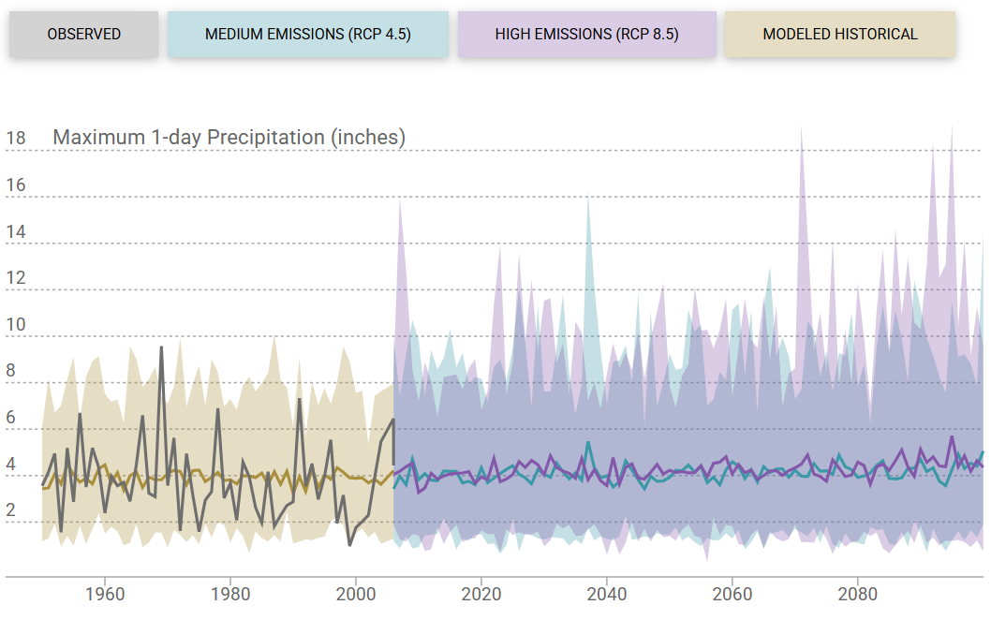
Table 3H below summarizes Cal-Adapt baseline and mid-century projections for Maximum 1-day Precipitation, which is the maximum daily amount of rain or snow over a 24-hour period.
Table 3H: Maximum 1-day Precipitation (Cal-Adapt Projections)
Time Period | Change from Baseline | 30-Year Average | 30-year Range
Baseline (1961-1990) | -- | 3.892 inches | 3.399 – 4.338 inches
Mid-century (2035-2064)
RCP 4.5 | +0.181 inches | 4.073 inches | 3.337 – 4.819 inches
RCP 8.5 | +0.293 inches | 4.185 inches | 3.445 – 5.107 inches
Source: Cal-Adapt, Local Climate Snapshot for Crestline. From California’s Fourth Climate Change Assessment.
RCP: representative concentration pathway; 4.5: medium emissions scenario; 8.5: high emissions scenario.
Maximum Length of Dry Spell is the maximum length of dry spell for each year. In other words, the maximum number of consecutive days with precipitation less than one millimeter for each year. Chart 3-6 shows the most likely outcome and range of future projections of Maximum Length of Dry Spell in the Crestline area.
Chart 3-6 – Cal-Adapt Projections for Maximum Length of Dry Spell
(Source: Cal-Adapt, Local Climate Snapshot for Crestline)
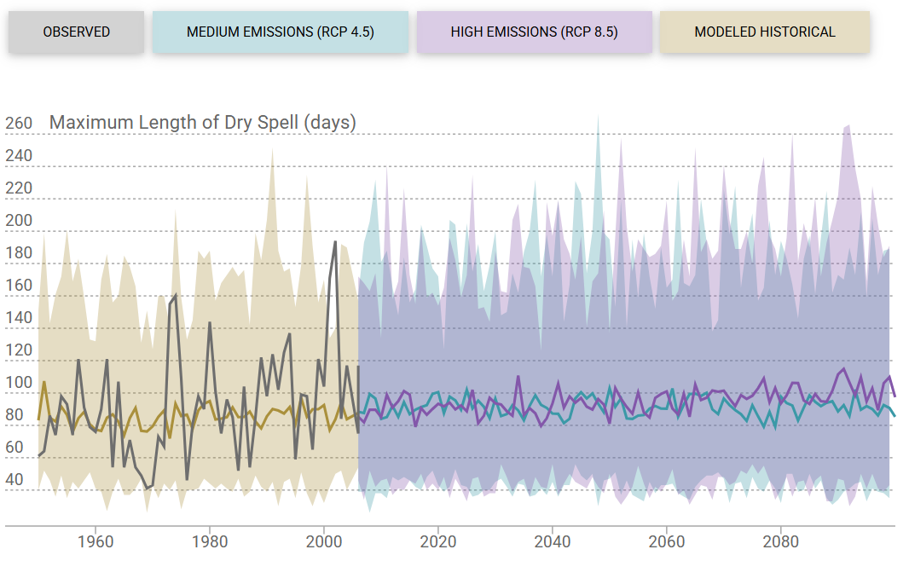
Table 3I below summarizes Cal-Adapt baseline and mid-century projections for Maximum Length of Dry Spell, which is maximum number of consecutive days with precipitation less than 1 millimeter for each year.
Table 3I: Maximum Length of Dry Spell (Cal-Adapt Projections)
Time Period | Change from Baseline | 30-Year Average | 30-year Range
Baseline (1961-1990) | -- | 84 days | 74 – 96 days
Mid-century (2035-2064)
RCP 4.5 | + 8 days | 92 days | 71 – 121 days
RCP 8.5 | + 8 days | 92 days | 65 – 122 days
Source: Cal-Adapt, Local Climate Snapshot for Crestline. From California’s Fourth Climate Change Assessment.
RCP: representative concentration pathway; 4.5: medium emissions scenario; 8.5: high emissions scenario.
Annual Precipitation is the total precipitation projected for a year. Chart 3-7 shows the most likely outcome and range of future projections of Annual Precipitation in the Crestline area.
Chart 3-7 – Cal-Adapt Projections for Annual Precipitation
(Source: Cal-Adapt, Local Climate Snapshot for Crestline)
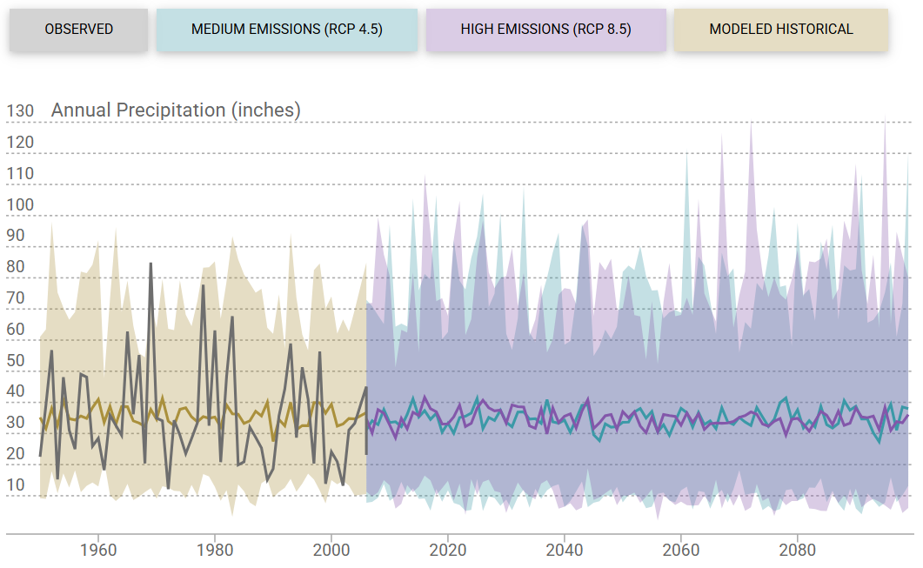
Table 3J below summarizes Cal-Adapt baseline and mid-century projections for Annual Precipitation in the Crestline area, which is the total precipitation in a year.
Table 3J: Annual Precipitation (Cal-Adapt Projections)
Time Period | Change from Baseline | 30-Year Average | 30-year Range
Baseline (1961-1990) | -- | 35.5 inches | 31.1 – 38.5 inches
Mid-century (2035-2064)
RCP 4.5 | -1.3 inches | 34.2 inches | 26.3 – 44.4 inches
RCP 8.5 | -1.0 inches | 34.5 inches | 26.6 – 44.9 inches
Source: Cal-Adapt, Local Climate Snapshot for Crestline. From California’s Fourth Climate Change Assessment.
RCP: representative concentration pathway; 4.5: medium emissions scenario; 8.5: high emissions scenario.
The Standardized Precipitation-Evaporation Index (SPEI)—new in the 2025 CVWD UWMP—depicts the combined impacts of precipitation deficits and potential evapotranspiration on soil moisture. SPEI does not include impacts from effects like wind speed, relative humidity or solar radiation impacts (typically short-term forcing), making it more reflective of long-term hydrological and ecological drought conditions. A value less than -1 implies the drought is at least moderate in intensity, with more negative values representing more severe droughts. Chart 3-8 shows the most likely outcome and range of future projections of SPEI in the Crestline area.
Chart 3-8 – Cal-Adapt Projections for Standardized Precipitation-Evapotranspiration Index (SPEI)
(Source: Cal-Adapt, Local Climate Snapshot for Crestline)
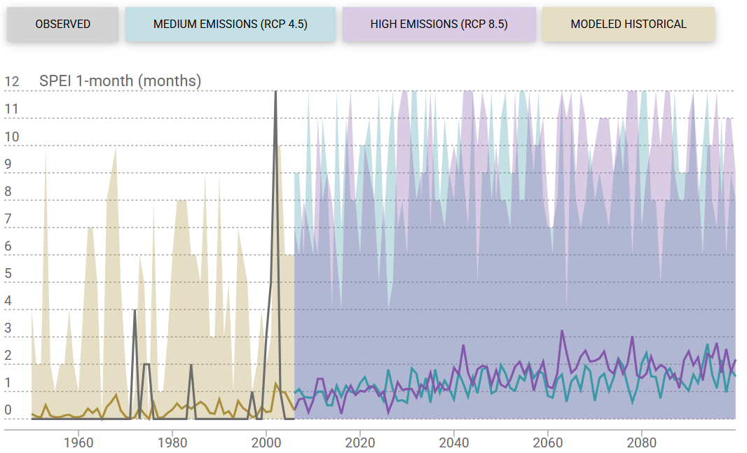
Table 3K below summarizes Cal-Adapt baseline and mid-century projections for SPEI 1-month in the Crestline area.
Table 3K: SPEI, 1-Month (Cal-Adapt Projections)
Time Period | Change from Baseline | 30-Year Average | 30-year Range
Baseline (1961-1990) | -- | 0.3 months | 0.0 – 1.1 months
Mid-century (2035-2064)
RCP 4.5 | +1.0 months | 1.3 months | 0.2 – 2.7 months
RCP 8.5 | -1.0 inches | 1.7 months | 0.5 – 3.5 months
Source: Cal-Adapt, Local Climate Snapshot for Crestline. From California’s Fourth Climate Change Assessment.
RCP: representative concentration pathway; 4.5: medium emissions scenario; 8.5: high emissions scenario.

Uncertainty Inherent in Climate Projections
All climate projections, regardless of source, are meant to approximate future climate conditions. As with any projections of the future, some degree uncertainty is inherent. "Uncertainty” in this case is meant scientifically—that there is a range of possible future outcomes, This is graphically illustrated in the charts above. Sources of uncertainty in these projections include the degree of greenhouse gas emissions on which the models are based, how various models and tools around the world represent different aspects of climate systems, and how well those aspects of the climate systems are understood.
Climate scientists constantly striving to improver climate theory and the tools they employ to develop and present projections for future climate. Looking at projections from as many different models as possible is one way to get a range of possible outcomes that averages into a more likely outcome as opposed to simply looking at one model. The concept that climate change is occurring and is caused by human activity is the consensus of the overwhelming majority of climate scientists throughout the world. The uncertainty lies within how much climate will change in the future and what its impact will be on humans, nature, and water systems.

Service Area Population and Demographics

Service Area Population
The CVWD service area includes residential, commercial, and institutional customers. The existing commercial businesses are oriented to tourists, seasonal, and permanent residents. The development pattern in the CVWD service area is primarily detached single-family residential, which is expected to continue for the duration of the planning period. Spikes in population, and therefore water use, occur seasonally and during times of economic growth.
The unincorporated community of Crestline including the community of Lake Gregory makes up a majority of the District’s service area. A portion of the Valley of Enchantment and a portion of the Twin Peaks communities are also included in the service area. Crestline and neighboring communities are part of a mountain resort area that experiences significant tourism. There is a large seasonal population component as well as a substantial influx of visitors, which can quickly double the population. The seasonal population is not reflected in available demographic statistics that count only year-round residents. Seasonal changes in water demand in the mountain area are different from the normal seasonal variation in water use by customers in non-mountain areas, which reflect spikes in water demand for landscape irrigation, swimming pools, car washing, space cooling, etc. By contrast, Crestline and neighboring mountain resort areas experience significant seasonal swings in the number of people served, with peaks in both summer and winter due to the abundance of recreational activities within the mountain communities.
CVWD estimates a 2025 District population of 11,650 persons, as shown in Submittal Table 3-1. Calculations are included in Appendix H.
Submittal Table 3-1: Population – Current and Projected
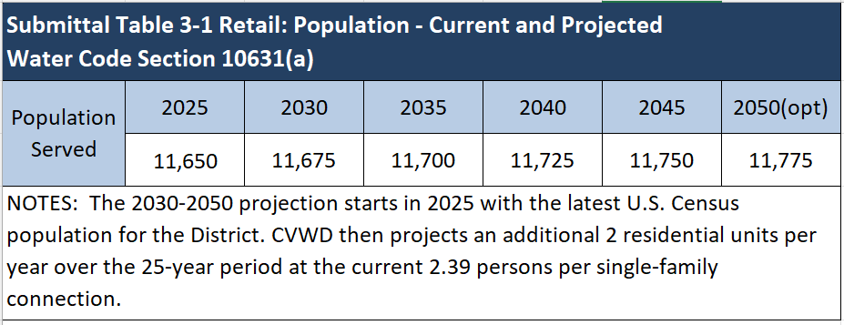

Population Projection 2025-2050
The Water Code does not require a specific method for projecting future population in the UWMP, but it does require that the estimates of future population be based upon data from state, regional, or local service agency population projections. First, CVWD looked to the most recent Transportation Analysis Zone (TAZ) GIS data from the Southern California Association of Governments (SCAG). The TAZ data provides an estimate of total households in 2019, 2035, and 2050. This data generated an annual growth rate within the CVWD boundary that was unrealistic.
Therefore, to estimate future growth over the 25-year period, the District took several aspects of the community into account:
- the limited potential for growth in this mountainous community due to lack of developable land
- the District surrounded by the San Bernardino National Forest on all sides
- historical almost non-existent growth over the past few decades
- a high percentage of part-time residents
Based on the District’s knowledge of its community, future population growth is based on two additional residential units per year over the next 25 years at the current persons-per-household ratio of 2.39, which is a growth rate of 0.43 percent per year. This would result in an increase over 25 years of 50 more residential units and an increase in the population of approximately 120 people.

Accessory Dwelling Units
Accessory dwelling units (ADUs) are also known as “granny flats,” second units, or in-law units. They can be for one or more people and can be detached, attached, existing space converted into an independent living unit, or a Junior ADU contained entirely within an existing or proposed single-family residence. ADUs are being encouraged by the State to increase residential infill and help meet the increasing statewide demand for affordable housing. Because the ADU laws (Gov. Code 65852.2) change each year, readers should refer to the California Department of Housing and Community Development (www.hcd.ca.gov) for the latest changes to the law.
An increase in ADUs in existing residential areas may densify them more than what had been planned for previously by CVWD. Particularly in areas that are considered currently “built-out” with infrastructure that is already sized at “ultimate” design capacity, an increase in ADUs may trigger capital projects to upsize existing pipes or replace degrading infrastructure earlier than expected.
As presented below in Section 3.5, WEBB requested land use data for this UWMP from the San Bernardino County Land Use Services Department. According to a 4/28/2026 email from County Land Use Services Director Miguel Figueroa, there were six new ADUs being reviewed at the time by County Land Use Services staff. The additional water demand associated with ADUs being constructed currently is considered minimal and within the margin of error of water demands between the permanent full-time residents and the temporary part-time residents. Therefore, the projected water demands in this plan do not include an inflator for water demands from potential future ADU’s.

Other Social, Economic, and Demographic Factors
The CVWD service area is within the San Bernardino County the Crest Forest Communities, which encompasses Crestline, Cedarpines Park, Lake Gregory, and Valley of Enchantment.
In the 1840s, the mountains became popular for timber harvesting and as a summer vacation spot, and by 1906 Henry Guernsey had developed what is now Crestline as a second home community. Completion of the 101-mile Rim of the World Highway in 1915 improved access to the mountains, and in 1923 summer and winter resorts were opened in Skyland. During the 1920s, the Valley of Enchantment, Crestline, Skyland, and Cedarpines Park were further developed with residential uses, serving primarily as vacation homes. From 1936 to 1938, the Works Progress Administration constructed the dam that created Lake Gregory, and in 1977 Lake Gregory was deeded to the County as a regional park.
Over the years, the Crest Forest area has gradually developed into less of a resort or second-home community and more of a bedroom community, composed of predominantly low-density, single-family residential areas. The area is oriented toward family recreation, with Lake Gregory serving as the main tourist attraction (Crest Forest Communities “Community Profile” Working Draft).

District’s Calculation of Current (2025) Full-Time Residents
The District calculates an estimate of the “full-time” population as the number of residential meters with a local billing zip code (92325) multiplied by the number of persons per single-family meter (2.39), and then an estimation of persons per multi-family meter (estimated from water use compared as a percentage from that of single family meters—3%). According to District records, the percentage of full-time customers currently constitutes 55 percent of total connections, which is close to the average percentage over the past 25 years, but this has fluctuated considerably over time in response to economic up/downturns. Over the past 25 years, the proportion of full-time residents has been as high as 61.5 percent in 2004, and as low as 53.3 percent in 1995.

Disadvantaged Communities
U.S. Census data is gathered at three levels of precision: at the broadest level for unincorporated areas is the Census Designated Place (CDP), followed by Census Tracts that are made up of Block Groups. California Code of Regulations Section 596.1(b)(2) defines a “disadvantaged community (DAC)” as, “A community with an annual median household income (MHI) that is less than 80 percent of the statewide annual MHI.” The statewide MHI according to the Census American Community Survey (ACS) 2019-2023 dataset is $96,334; thus, 80 percent and 60 percent of that value represents the DAC and Severely DAC (SDAC) thresholds, respectively. Therefore, a community where the MHI is less than $77,067 meets the DAC threshold and a MHI less than $57,800 meets the SDAC threshold (ACS). According to the U.S. Census Bureau “QuickFacts,” the Crestline Census Designated Place as a whole has a medium household income from 2020-2024 of $70,563 (in 2019 dollars) (USCB).
The Census Block Groups that qualify as “disadvantaged” and “severely disadvantaged” are shown in Figure 3-3 – Disadvantaged Community by Census Block Group. The information contained in Figure 3-3 is taken directly from the DWR Web site feature called, “Disadvantaged Communities (DAC) Mapping Tool.” The mapping tool is a reference to assist local agencies to evaluate DAC status. Having areas that qualify as a DAC opens the District to the possibility of applying for State grant funding to assist with the implementation, planning, and disadvantaged community involvement efforts.

service area land use
Development in the San Bernardino Mountains is naturally constrained by the terrain, limited access, and lack of support infrastructure, as well as policies that place much of the area off-limits to significant development. Most of the mountain area, including the majority of CVWD’s service area, is surrounded by or within the San Bernardino National Forest (Figure 3-2). Forest lands are devoted primarily to resource protection and recreational use; however, they do become available for development from time to time, but it is extremely rare.

Coordination with the Land Use Authority
CVWD does not have land use authority within its service area. Because the CVWD service area is located within the unincorporated territory of San Bernardino County, land use authority rests with San Bernardino County. On behalf of CVWD, WEBB contacted the San Bernardino County Land Use Services Department on April 23, 2026, specifically for the purpose of coordinating for this UWMP to request current land use information. A copy of the email request is included in Appendix E. Said email requested data from the County on the following questions:
- Is the County preparing for any large-scale projects proposed within the District service area?
- Does the County have information on recent or pending permits for accessory dwelling units (ADUs)?
- Does the County have any other land use-related information that may affect the District’s projections for future water use in the next 20-25 years?
The County Land Use Services Department responded on April 28, 2026, with the following information: There are no large scale projects currently planned within the District. Also, only six (6) ADUs had been approved during the previous six months, and those are currently in process. In addition, “No additional information to provide regarding projects/initiatives that may affect the District’s projections for future water use in the next 20-25 years.”

Community of Crestline Demographics
Crestline is an unincorporated census-designated community within the San Bernardino Mountains. According to the U.S. Census Bureau “QuickFacts” Web site, as of 2024 (the latest date for which Census data is available), the majority of the residents are white, not Hispanic or Latino (approximately 75%) and between the ages of 18 and 64 (approximately 60%). The majority of housing units are owner occupied (approximately 65%) and the average household size in Crestline from 2020 through 2024 was 2.53 persons. The median value of owner-occupied housing units is approximately $332,700 and the median gross rent is approximately $1,400. Median household income (in 2024 dollars) is approximately $80,700 and median income per capita (also in 2024 dollars) is approximately $44,700.
San Bernardino County’s General Plan, called the Countywide Plan (November 2020) uses a two-map system, under which there is a separate General Plan land use map and a separate zoning map. Refer to Figure 3-4 – Land Use Designations and Figure 3-5 – Zoning Designations. Land use designations within Crestline include residential, commercial, industrial, public facility, open space, and resource land management uses. As shown in Table 3L and Figure 3-4, the predominant land use in Crestline is residential. Based on maximum and mid-range projected number of dwelling units and 2.39 persons per dwelling unit, the maximum and mid-range population projections for the water service area are 18,850 and 13,071, respectively. Note that these projections are significantly higher than the population projections through 2050 shown in Submittal Table 3-1.
Table 3L: Summary of Maximum and Mid-Point Projected Buildouts
Based on Countywide Plan Land Use Designations
Countywide Plan Land Use Designation | Acres in CVWD Service Area | Maximum Projected DUs or SF of Non-Residential Uses | Mid-Point Projected DUs | Maximum Projected Population⁽¹⁾ | Mid-Range Projected Population⁽¹⁾
Residential | 1,958 | 7,774 DUs | 5,469 DUs | 18,850 | 13,071
Commercial⁾ | 94 | 3,067,713 SF | N/A | N/A | N/A
Industrial | 5 | 103,019 SF | N/A | N/A | N/A
Open Space | 596 | N/A | N/A | N/A | N/A
Public Facility | 181 | N/A | N/A | N/A | N/A
Totals | 2,834 | N/A | 5,469 | 18,850 | 13,071
Notes: DU = dwelling unit, SF = square feet.
- CVWD estimates persons per dwelling unit of 2.39.
- Refer to Appendix H for the detailed calculations used to produce this summary table.

County Zoning or Land Use Districts within Crestline include residential, agricultural and resource management (i.e., floodway, open space, and resource conservation), commercial, industrial, and special purpose (i.e., specific development and institutional). As shown in Table 3M and Figure 3-5, the predominant zoning in Crestline is residential. Based on maximum and mid-range projected number of dwelling units and 2.39 persons per dwelling unit, the maximum and mid-range population projections for the water service area are 16,773 and 13,071, respectively. Note that these projections are somewhat lower than the projections based on Countywide land use designations (shown in Table 3L) and are significantly higher than the population projections through 2045 shown in Submittal Table 3-1.
Table 3M: Summary of Maximum and Mid-Point Projected Buildouts
Based on Land Use Districts per County Development Code
Zoning (Land Use) District Per County Development Code (Title 8) | Acres within District Service Area | Maximum Projected DUs or SF of Non-Residential Uses | Mid-Point Projected DUs⁽¹⁾ | Maximum Projected Population⁽⁴⁾ | Mid-Range Projected Population⁽⁴⁾
Residential | 1,883 | 7,018 DUs | 5,469 DUs | 16,773 | 13,071
Commercial⁾ | 83 | 1,766,576 SF | N/A | N/A | N/A
Industrial | 5 | 82,416 SF | N/A | N/A | N/A
Agricultural and Resource Management⁽²⁾ | 499 | 10 | 10 | 25 | 25
Special Purpose⁽³⁾ | 364 | 1,328,580 SF | N/A | N/A | N/A
Totals | 2,834 | N/A | 5,469 | 16,773 | 13,071
Notes: DU = dwelling unit, SF = square feet.
- The County Development Code does not identify density ranges. The calculated mid-range density used for Single Residential and Multiple Residential is 2 DU/ac and 12.5 DU/ac, respectively.
- The Agricultural and Resource Management category includes Floodway, Open Space, and Resource Conservation. The Resource Conservation Land Use District allows 1 DU per 40 acres. Of the 499 acres in the Agricultural and Resource Management category, 361 acres are designated Resource Conservation.
- The Special Purpose category includes Specific Development and Institutional. The Institutional Land Use District allows a maximum FAR of 0.5. Of the 364 acres In the Special Purpose Category, 81 acres are designated Institutional.
- U.S. Census Bureau Quickfacts for Crestline from 2020-2024 estimates persons per dwelling unit of 2.39.
- Refer to Appendix H for the detailed calculations used to produce this summary table.

Insert
Figure 3-1 – Sphere of Influence

Figure 3-2 – San Bernardino National Forest Boundary

Insert
Figure 3-3 – Disadvantaged Community by Census Block Group

Insert
Figure 3-4 – San Bernardino County Land Use Designations

Insert
Figure 3-5 – San Bernardino County Zoning Categories

LAFCO, County of San Bernardino Resolution No. 3122, available at https://sbclafco.org/wp-content/uploads/sites/60/items/201101/item_7.pdf
Note the threshold temperature used in Cal-Adapt is location specific. It is defined as the 98th percentile value of historical daily maximum/minimum temperatures (from 1961–1990, between April and October) observed at a location.
Note the threshold temperature used in Cal-Adapt is location specific. It is defined as the 98th percentile value of recorded daily maximum/minimum temperatures (from 1961–1990, between April and October) observed at a location.
Persons per household ratio of 2.39 is from the U.S. Census QuickFacts for Crestline Census Designated Place 2020-2024 American Community Survey 5-year estimate (https://www.census.gov/quickfacts/fact/table/crestlinecdpcalifornia/LND110210).
This is consistent with 2020 SCAG Demographics and Growth Forecast Technical Report, which estimates an annual population growth rate for unincorporated San Bernardino County of 0.44 percent from 2016 to 2045.

